UNITED STATES
SECURITIES AND EXCHANGE COMMISSION
Washington, D.C. 20549
FORM 10-Q
(Mark One)
☒ |  |  | QUARTERLY REPORT PURSUANT TO SECTION 13 OR 15(d) OF THE SECURITIES EXCHANGE ACT OF 1934
For the quarterly period ended March 31, 2026
OR
☐ |  |  | TRANSITION REPORT PURSUANT TO SECTION 13 OR 15(d) OF THE SECURITIES EXCHANGE ACT OF 1934
For the transition period from ___ to ___
Commission file number 001-40653
Duolingo, Inc.
(Exact name of registrant as specified in its charter)
Delaware |  |  |  |  |  |  |  |  |  |  |  | 45-3055872
(State or other jurisdiction of incorporation or organization) |  |  |  |  |  |  |  |  |  |  |  | (I.R.S. Employer Identification No.)
5900 Penn Avenue
Pittsburgh, Pennsylvania 15206
(412) 567-6602
(Address, Including Zip Code, and Telephone Number, Including
Area Code, of Registrant’s Principal Executive Offices)
Securities registered pursuant to Section 12(b) of the Act:
Title of each class |  |  | Trading Symbol(s) |  |  | Name of each exchange on which registered
Class A common stock, $0.0001 per share |  |  | DUOL |  |  | The Nasdaq Stock Market LLC

Indicate by check mark whether the registrant: (1) has filed all reports required to be filed by Section 13 or 15(d) of the Securities Exchange Act of 1934 during the preceding 12 months (or for such shorter period that the registrant was required to file such reports); and (2) has been subject to such filing requirements for the past 90 days.
Yes ☒ No ☐
Indicate by check mark whether the registrant has submitted electronically every Interactive Data File required to be submitted pursuant to Rule 405 of Regulation S-T (§232.405 of this chapter) during the preceding 12 months (or for such shorter period that the registrant was required to submit such files).
Yes ☒ No ☐
Indicate by check mark whether the registrant is a large accelerated filer, an accelerated filer, a non-accelerated filer, a smaller reporting company, or an emerging growth company. See the definitions of “large accelerated filer,” “accelerated filer”, “smaller reporting company” and “emerging growth company” in Rule 12b-2 of the Exchange Act.
Large accelerated filer |  |  | ☒ |  |  |  |  |  | Accelerated filer |  |  | ☐
Non-accelerated filer |  |  | ☐ |  |  |  |  |  | Smaller reporting company |  |  | ☐
 |  |  |  |  |  |  |  |  | Emerging growth company |  |  | ☐
If an emerging growth company, indicate by check mark if the registrant has elected not to use the extended transition period for complying with any new or revised financial accounting standards provided pursuant to Section 13(a) of the Exchange Act. ☐
Indicate by check mark whether the registrant is a shell company (as defined in Rule 12b-2 of the Act). Yes ☐ No ☒
As of May 1, 2026, 40,237,065 shares of the registrant's Class A common stock were outstanding, and 6,356,052 shares of the registrant's Class B common stock were outstanding.

Table of Contents Page
Special Note Regarding Forward-Looking Statements |  |  | 2
Special Note Regarding Key Operating Metrics |  |  | 4
Part I Financial Information |  |  | 5
Item 1. Financial Statements (Unaudited) |  |  | 5
Item 2. Management's Discussion and Analysis of Financial Condition and Results of Operations |  |  | 20
Item 3. Quantitative and Qualitative Disclosures About Market Risk |  |  | 31
Item 4. Controls and Procedures |  |  | 32
Part II Other Information |  |  | 34
Item 1. Legal Proceedings |  |  | 34
Item 1A. Risk Factors |  |  | 34
Item 2. Unregistered Sales of Equity Securities and Use of Proceeds |  |  | 34
Item 3. Defaults Upon Senior Securities |  |  | 34
Item 4. Mine Safety Disclosures |  |  | 34
Item 5. Other Information |  |  | 34
Item 6. Exhibits |  |  | 36
Signatures |  |  | 37

1

Special Note Regarding Forward-Looking Statements
This Quarterly Report on Form 10-Q contains forward-looking statements within the meaning of the Private Securities Litigation Reform Act of 1995. We intend such forward-looking statements to be covered by the safe harbor provisions for forward-looking statements contained in Section 27A of the Securities Act of 1933, as amended (the “Securities Act”) and Section 21E of the Securities Exchange Act of 1934, as amended (the “Exchange Act”). All statements other than statements of historical facts contained in this Quarterly Report on Form 10-Q including without limitation, statements regarding our business model and strategic plans, including the introduction of new products, and our implementation thereof; statements regarding our expectations, beliefs, plans, objectives, prospects, assumptions, future events or expected performance, including our ability to compete in our industry; the sufficiency of our cash, cash equivalents and investments; and the plans and objectives of management for future operations and capital expenditures are forward-looking statements.
Without limiting the generality of the foregoing, you can identify forward-looking statements because they contain words such as “may,” “will,” “shall,” “should,” “expects,” “plans,” “anticipates,” “could,” “intends,” “target,” “projects,” “contemplates,” “believes,” “estimates,” “predicts,” “potential,” “goal,” “objective,” “seeks,” or “continue” or the negative of these words or other similar terms or expressions that concern our expectations, strategy, plans, or intentions. Such forward-looking statements are neither promises nor guarantees, but involve a number of known and unknown risks, uncertainties and assumptions that may cause our actual results, performance or achievements to differ materially from those expressed or implied in the forward-looking statements due to various factors, including, but not limited to:
•our ability to retain and grow our users and sustain their engagement with our products;
•competition in the online language learning industry;
•our ability to maintain profitability;
•the impact on our income as a result of the release of valuation allowances on deferred tax assets;
•our expectations regarding fluctuations in our effective tax rate, including changes to valuation allowances, and the adequacy of our reserves;
•our ability to manage our growth and operate at such scale;
•the success of our investments;
•our ability to accurately predict our quarterly operating results and other operating metrics;
•our ability to accurately measure our user metrics and other operating metrics;
•our reliance on third-party platforms to store and distribute our products and collect revenue;
•the success of our development, implementation and use of artificial intelligence and machine learning technologies;
•our reliance on third-party hosting, cloud computing providers and Artificial Intelligence (“AI”) vendors;
•our ability to compete for advertisements;
•acceptance by educational organizations of technology-based education;
•changes in our business and macroeconomic conditions;
2

•the accuracy of market research published about the Company by third-party data scraping services;
•those identified in Part I, Item 2. “Management’s Discussion and Analysis of Financial Condition and Results of Operations in this Quarterly Report on Form 10-Q; and
•those identified in Part I, Item 1A. “Risk Factors” and Part II, Item 7. “Management’s Discussion and Analysis of Financial Condition and Results of Operations” in our Annual Report on Form 10-K for the fiscal year ended December 31, 2025 (the “Annual Report on Form 10-K”).
We caution you that the foregoing list does not contain all of the forward-looking statements made in this Quarterly Report on Form 10-Q.
You should not rely upon forward-looking statements as predictions of future events. We have based the forward-looking statements contained in this Quarterly Report on Form 10-Q primarily on our current expectations, estimates, forecasts, and projections about future events and trends that we believe may affect our business, financial condition, results of operations and prospects. These statements are based upon information available to us as of the date of this Quarterly Report on Form 10-Q and, although we believe that we have a reasonable basis for each forward-looking statement contained in this Quarterly Report on Form 10-Q, such information may be limited or incomplete, and our statements should not be read to indicate that we have conducted an exhaustive inquiry into, or review of, all potentially available relevant information. We cannot guarantee that the future results, levels of activity, performance, or events and circumstances reflected in the forward-looking statements will be achieved or occur at all. Moreover, we operate in a very competitive and rapidly changing environment. The results, events, and circumstances reflected in the forward-looking statements may not be achieved or occur, and actual results, events, or circumstances could differ materially from those described in the forward-looking statements. You should not place undue reliance on our forward-looking statements.
The forward-looking statements made in this Quarterly Report on Form 10-Q relate only to events as of the date on which the statements are made. While we may elect to update such forward-looking statements at some point in the future, unless required by applicable law, we disclaim any obligation to do so, even if subsequent events cause our views to change.
You should read this Quarterly Report on Form 10-Q and the documents that we reference in this Quarterly Report on Form 10-Q completely and with the understanding that our actual future results may be materially different from what we expect. We qualify all of the forward-looking statements in this Quarterly Report on Form 10-Q by these cautionary statements.
Unless the context otherwise requires, all references in this Quarterly Report on Form 10-Q to “Duolingo,” the “Company”, “we,” “our,” “us,” or similar terms refer to Duolingo, Inc. and its subsidiaries.

3

Special Note Regarding Key Operating Metrics
We manage our business by tracking several operating metrics, including daily active users (DAUs), paid subscribers, subscription bookings, and total bookings. We believe each of these operating metrics provides useful information to investors and others. For information concerning these metrics as measured by us, see Part I, Item 2. “Management’s Discussion and Analysis of Financial Condition and Results of Operations - Key Operating Metrics and Non-GAAP Financial Measures.”
While these metrics are based on what we believe to be reasonable estimates of our user base for the applicable period of measurement, there are inherent challenges in measuring how our platform is used. These metrics are determined by using internal data gathered on an analytics platform that we developed and operate and have not been validated by an independent third party. This platform tracks user account and session activity. If we fail to maintain an effective analytics platform, our metrics calculations may be inaccurate.
We believe that these metrics are reasonable estimates of our user base for the applicable period of measurement, and that the methodologies we employ and update from time-to-time to create these metrics are reasonable bases to identify trends in user behavior. Because we update the methodologies we employ to create metrics, our operating metrics may not be comparable to those in prior periods. See “Risk Factors—Our user metrics and other operating metrics are subject to inherent challenges in measurement, and real or perceived inaccuracies in those metrics may negatively affect our reputation and our business” included in the Annual Report on Form 10-K. Other companies, including companies in our industry, may calculate these metrics differently.

4

Part I Financial Information

Item 1. Financial Statements (Unaudited)

5

DUOLINGO, INC. AND SUBSIDIARIES
UNAUDITED CONDENSED CONSOLIDATED BALANCE SHEETS
(Amounts in thousands, except par value amounts)
 |  |  | March 31,  2026 |  |  |  |  |  | December 31, 2025
ASSETS
Current assets
Cash and cash equivalents |  |  | $ | 1,138,561 |  |  |  |  | $ | 1,036,389
Short-term investments |  |  | 113,049 |  |  |  |  |  | 104,078
Accounts receivable |  |  | 125,086 |  |  |  |  |  | 162,827
Deferred cost of revenues |  |  | 104,513 |  |  |  |  |  | 102,663
Income tax receivable |  |  | 5,092 |  |  |  |  |  | 14,067
Prepaid expenses and other current assets |  |  | 19,658 |  |  |  |  |  | 16,582
Total current assets |  |  | 1,505,959 |  |  |  |  |  | 1,436,606
Operating lease right-of-use assets |  |  | 79,944 |  |  |  |  |  | 80,380
Long-term investments |  |  | 140,211 |  |  |  |  |  | 135,098
Intangible assets, net |  |  | 28,327 |  |  |  |  |  | 28,309
Property and equipment, net |  |  | 36,966 |  |  |  |  |  | 36,297
Goodwill |  |  | 35,335 |  |  |  |  |  | 35,335
Restricted cash |  |  | 2,735 |  |  |  |  |  | 2,735
Deferred tax assets, net |  |  | 217,837 |  |  |  |  |  | 227,339
Other assets |  |  | 10,680 |  |  |  |  |  | 10,083
Total assets |  |  | $ | 2,057,994 |  |  |  |  | $ | 1,992,182
LIABILITIES AND STOCKHOLDERS’ EQUITY
Current liabilities
Deferred revenues |  |  | $ | 513,256 |  |  |  |  | $ | 496,205
Accounts payable |  |  | 7,486 |  |  |  |  |  | 7,998
Income tax payable |  |  | 3,814 |  |  |  |  |  | 1,257
Accrued expenses and other current liabilities |  |  | 49,558 |  |  |  |  |  | 45,688
Total current liabilities |  |  | 574,114 |  |  |  |  |  | 551,148
Long-term obligation under operating leases |  |  | 91,873 |  |  |  |  |  | 93,779
Deferred tax liabilities, net |  |  | 243 |  |  |  |  |  | 249
Other long-term liabilities |  |  | — |  |  |  |  |  | —
Total liabilities |  |  | 666,230 |  |  |  |  |  | 645,176
Commitments and contingencies (Note 9)
Stockholders’ equity
Class A common stock, $0.0001 par value; 2,000,000 shares authorized as of March 31, 2026 and December 31, 2025; 40,534 issued and 40,487 outstanding at March 31, 2026 and 40,368 issued and outstanding at December 31, 2025, respectively  Class B common stock, $0.0001 par value; 30,000 shares authorized as of March 31, 2026 and December 31, 2025; 6,356 and 6,260 issued and outstanding at March 31, 2026 and December 31, 2025, respectively |  |  | 5 |  |  |  |  |  | 5
Treasury stock, at cost; 46 and 0 shares as of March 31, 2026 and December 31, 2025, respectively. |  |  | (4,499) |  |  |  |  |  | —
Additional paid-in capital |  |  | 1,064,580 |  |  |  |  |  | 1,058,783
Retained earnings |  |  | 331,678 |  |  |  |  |  | 288,218
Total stockholders’ equity |  |  | 1,391,764 |  |  |  |  |  | 1,347,006
Total liabilities and stockholders' equity |  |  | $ | 2,057,994 |  |  |  |  | $ | 1,992,182
See accompanying notes to the Unaudited Condensed Consolidated Financial Statements.

6

DUOLINGO, INC. AND SUBSIDIARIES
UNAUDITED CONDENSED CONSOLIDATED STATEMENTS OF OPERATIONS AND COMPREHENSIVE INCOME
(Amounts in thousands, except per share amounts)
 |  |  | Three Months Ended March 31,
 |  |  | 2026 |  |  |  |  |  | 2025
Revenues |  |  | $ | 291,967 |  |  |  |  | $ | 230,743
Cost of revenues |  |  | 78,871 |  |  |  |  |  | 66,647
Gross profit |  |  | 213,096 |  |  |  |  |  | 164,096
Operating expenses:
Research and development |  |  | 82,974 |  |  |  |  |  | 70,390
Sales and marketing |  |  | 39,249 |  |  |  |  |  | 26,662
General and administrative |  |  | 46,346 |  |  |  |  |  | 43,450
Total operating expenses |  |  | 168,569 |  |  |  |  |  | 140,502
Income from operations |  |  | 44,527 |  |  |  |  |  | 23,594
Other (expense) income, net |  |  | (786) |  |  |  |  |  | 1,001
Income before interest income and income taxes |  |  | 43,741 |  |  |  |  |  | 24,595
Interest income |  |  | 11,811 |  |  |  |  |  | 10,415
Income before income taxes |  |  | 55,552 |  |  |  |  |  | 35,010
Provision for (benefit from) income taxes |  |  | 12,092 |  |  |  |  |  | (125)
Net income and comprehensive income |  |  | $ | 43,460 |  |  |  |  | $ | 35,135
Net income per share attributable to Class A and Class B common stockholders, basic |  |  | $ | 0.93 |  |  |  |  | $ | 0.78
Net income per share attributable to Class A and Class B common stockholders, diluted |  |  | $ | 0.89 |  |  |  |  | $ | 0.72
See accompanying notes to the Unaudited Condensed Consolidated Financial Statements.

7

DUOLINGO, INC. AND SUBSIDIARIES
UNAUDITED CONDENSED CONSOLIDATED STATEMENTS OF STOCKHOLDERS’ EQUITY
(Amounts in thousands)
 |  |  | Common Stock |  |  |  |  |  |  |  |  |  |  |  | Treasury Stock
 |  |  | Shares |  |  |  |  |  | Amount |  |  |  |  |  | Shares |  |  |  |  |  | Amount |  |  |  |  |  | Additional Paid-In  Capital |  |  |  |  |  |  |  | (Accumulated  Deficit)  Retained Earnings |  |  |  |  |  |  |  |  | Total
BALANCE—January 1, 2025 |  |  | 44,936 |  |  |  |  |  | $ | 4 |  |  |  |  | — |  |  |  |  |  | $ | — |  |  |  |  | $ | 950,393 |  |  |  |  |  |  | $ | (125,847) |  |  |  |  |  |  |  | $ | 824,550
Stock-based compensation expense |  |  | — |  |  |  |  |  | — |  |  |  |  |  | — |  |  |  |  |  | — |  |  |  |  |  | 31,018 |  |  |  |  |  |  |  | — |  |  |  |  |  |  |  |  | 31,018
Stock options exercised |  |  | 276 |  |  |  |  |  | — |  |  |  |  |  | — |  |  |  |  |  | — |  |  |  |  |  | 3,123 |  |  |  |  |  |  |  | — |  |  |  |  |  |  |  |  | 3,123
Release of restricted stock units |  |  | 204 |  |  |  |  |  | — |  |  |  |  |  | — |  |  |  |  |  | — |  |  |  |  |  | — |  |  |  |  |  |  |  | — |  |  |  |  |  |  |  |  | —
Net income |  |  | — |  |  |  |  |  | — |  |  |  |  |  | — |  |  |  |  |  | — |  |  |  |  |  | — |  |  |  |  |  |  |  | 35,135 |  |  |  |  |  |  |  |  | 35,135
BALANCE—March 31, 2025 |  |  | 45,416 |  |  |  |  |  | $ | 4 |  |  |  |  | — |  |  |  |  |  | $ | — |  |  |  |  | $ | 984,534 |  |  |  |  |  |  | $ | (90,712) |  |  |  |  |  |  |  | $ | 893,826
BALANCE—January 1, 2026 |  |  | 46,628 |  |  |  |  |  | $ | 5 |  |  |  |  | — |  |  |  |  |  | $ | — |  |  |  |  | $ | 1,058,783 |  |  |  |  |  |  | $ | 288,218 |  |  |  |  |  |  |  | $ | 1,347,006
Stock-based compensation expense |  |  | — |  |  |  |  |  | — |  |  |  |  |  | — |  |  |  |  |  | — |  |  |  |  |  | 34,647 |  |  |  |  |  |  |  | — |  |  |  |  |  |  |  |  | 34,647
Release of performance stock units |  |  | 180 |  |  |  |  |  | — |  |  |  |  |  | — |  |  |  |  |  | — |  |  |  |  |  | — |  |  |  |  |  |  |  | — |  |  |  |  |  |  |  |  | —
Taxes paid related to net-share settlement of share-based compensation awards |  |  | (84) |  |  |  |  |  | — |  |  |  |  |  | — |  |  |  |  |  | — |  |  |  |  |  | (9,441) |  |  |  |  |  |  |  | — |  |  |  |  |  |  |  |  | (9,441)
Stock options exercised |  |  | 190 |  |  |  |  |  | — |  |  |  |  |  | — |  |  |  |  |  | — |  |  |  |  |  | 1,922 |  |  |  |  |  |  |  | — |  |  |  |  |  |  |  |  | 1,922
Release of restricted stock units |  |  | 191 |  |  |  |  |  | — |  |  |  |  |  | — |  |  |  |  |  | — |  |  |  |  |  | — |  |  |  |  |  |  |  | — |  |  |  |  |  |  |  |  | —
Repurchases of common stock |  |  | — |  |  |  |  |  | — |  |  |  |  |  | (262) |  |  |  |  |  | (25,830) |  |  |  |  |  | — |  |  |  |  |  |  |  | — |  |  |  |  |  |  |  |  | (25,830)
Retirement of treasury stock |  |  | (216) |  |  |  |  |  | — |  |  |  |  |  | 216 |  |  |  |  |  | 21,331 |  |  |  |  |  | (21,331) |  |  |  |  |  |  |  | — |  |  |  |  |  |  |  |  | —
Net income |  |  | — |  |  |  |  |  | — |  |  |  |  |  | — |  |  |  |  |  | — |  |  |  |  |  | — |  |  |  |  |  |  |  | 43,460 |  |  |  |  |  |  |  |  | 43,460
BALANCE—March 31, 2026 |  |  | 46,889 |  |  |  |  |  | $ | 5 |  |  |  |  | (46) |  |  |  |  |  | $ | (4,499) |  |  |  |  | $ | 1,064,580 |  |  |  |  |  |  | $ | 331,678 |  |  |  |  |  |  |  | $ | 1,391,764
See accompanying notes to the Unaudited Condensed Consolidated Financial Statements.

8

DUOLINGO, INC. AND SUBSIDIARIES
UNAUDITED CONDENSED CONSOLIDATED STATEMENTS OF CASH FLOWS
(Amounts in thousands)
 |  |  | Three Months Ended March 31,
 |  |  | 2026 |  |  |  |  |  | 2025
Cash flows from operating activities:
Net income |  |  | $ | 43,460 |  |  |  |  | $ | 35,135
Adjustments to reconcile net income to net cash provided by operating activities:
Deferred income taxes |  |  | 9,496 |  |  |  |  |  | —
Stock-based compensation expense |  |  | 34,647 |  |  |  |  |  | 31,018
Depreciation and amortization |  |  | 4,191 |  |  |  |  |  | 3,590
Accretion on marketable securities, net |  |  | (321) |  |  |  |  |  | (550)
Changes in assets and liabilities:
Deferred revenue |  |  | 17,051 |  |  |  |  |  | 42,139
Accounts receivable |  |  | 37,741 |  |  |  |  |  | 14,740
Deferred cost of revenues |  |  | (1,850) |  |  |  |  |  | (9,402)
Prepaid expenses and other current assets |  |  | 5,899 |  |  |  |  |  | (1,772)
Accounts payable |  |  | (2,405) |  |  |  |  |  | (3,843)
Accrued expenses and other current liabilities |  |  | 5,964 |  |  |  |  |  | (6,204)
Noncurrent assets and liabilities |  |  | (3,102) |  |  |  |  |  | 780
Net cash provided by operating activities |  |  | 150,771 |  |  |  |  |  | 105,631
Cash flows from investing activities:
Purchases of investments |  |  | (56,155) |  |  |  |  |  | (26,606)
Maturities and paydowns of investments |  |  | 42,391 |  |  |  |  |  | 18,676
Capitalized software expense and purchases of intangible assets |  |  | (2,853) |  |  |  |  |  | (1,310)
Purchase of property and equipment |  |  | (132) |  |  |  |  |  | (1,309)
Net cash used for investing activities |  |  | (16,749) |  |  |  |  |  | (10,549)
Cash flows from financing activities:
Proceeds from exercise of stock options |  |  | 1,922 |  |  |  |  |  | 3,123
Repurchase of common stock |  |  | (24,331) |  |  |  |  |  | —
Taxes paid related to net-share settlement of share-based compensation awards |  |  | (9,441) |  |  |  |  |  | —
Net cash (used for) provided by financing activities |  |  | (31,850) |  |  |  |  |  | 3,123
Net increase in cash, cash equivalents and restricted cash |  |  | 102,172 |  |  |  |  |  | 98,205
Cash, cash equivalents and restricted cash - Beginning of period |  |  | 1,039,124 |  |  |  |  |  | 788,526
Cash, cash equivalents and restricted cash - End of period |  |  | $ | 1,141,296 |  |  |  |  | $ | 886,731
See accompanying notes to the Unaudited Condensed Consolidated Financial Statements.

9

DUOLINGO, INC. AND SUBSIDIARIES
SUPPLEMENTAL DISCLOSURE OF CASH FLOW INFORMATION
(Amounts in thousands)
 |  |  | Three Months Ended March 31,
 |  |  | 2026 |  |  |  |  |  | 2025
Supplemental disclosure of cash flow information:
Cash paid for income taxes |  |  | $ | 19 |  |  |  |  | $ | 87
Supplemental disclosure of noncash investing activities:
Property and equipment included in Current liabilities |  |  | $ | 1,893 |  |  |  |  | $ | 162
Landlord incentive included in Other assets |  |  | $ | 6,809 |  |  |  |  | $ | —
Right of use assets obtained in exchange for new operating lease liabilities |  |  | $ | 1,918 |  |  |  |  | $ | —
Supplemental disclosure of noncash financing activities:
Repurchases of common stock included in Current liabilities |  |  | $ | 1,499 |  |  |  |  | $ | —
See accompanying notes to the Unaudited Condensed Consolidated Financial Statements.

10

DUOLINGO, INC. AND SUBSIDIARIES
NOTES TO THE UNAUDITED CONDENSED CONSOLIDATED FINANCIAL STATEMENTS

1. DESCRIPTION OF THE BUSINESS AND BASIS OF PRESENTATION
Duolingo, Inc. (the “Company” or “Duolingo”) was formed on August 18, 2011, and the Duolingo App was launched to the general public on June 19, 2012. The Company’s headquarters are located in Pittsburgh, Pennsylvania.
Duolingo is a mobile learning platform, as well as a digital English language proficiency assessment exam. The Company has a freemium business model: the app and the website are accessible free of charge, although Duolingo also offers premium services for a subscription fee. As of the date of this filing, Duolingo offers over 250 total language courses, including Spanish, English, French, German, Italian, Portuguese, Japanese and Chinese. We have locations in the U.S., China, Germany, and the United Kingdom.
Principles of Consolidation—The Unaudited Condensed Consolidated Financial Statements include the accounts of the Company and subsidiaries over which the Company has control. All intercompany transactions and balances have been eliminated.
Basis of Presentation—The accompanying Unaudited Condensed Consolidated Financial Statements have been prepared in accordance with generally accepted accounting principles in the U.S. (“GAAP”) from the Company’s accounting records and reflect the consolidated financial position and results of operations for the three months ended March 31, 2026 and 2025. Unless otherwise specified, all dollar amounts (other than per share amounts) are referred to in thousands.
The Unaudited Condensed Consolidated Financial Statements have been prepared pursuant to the rules and regulations of the Securities and Exchange Commission (“SEC”). Certain information and note disclosures normally included in financial statements prepared in accordance with GAAP have been condensed or omitted pursuant to such SEC rules. We believe that the disclosures made are adequate to make the information presented not misleading. In our opinion, all adjustments considered necessary for a fair presentation of the financial statements have been included, and all adjustments are of a normal and recurring nature. We applied the accounting policies consistently with those used in the preparation of the Annual Report on Form 10-K in preparing these Unaudited Condensed Consolidated Financial Statements in this Quarterly Report on Form 10-Q. These Unaudited Condensed Consolidated Financial Statements should be read in conjunction with the audited financial statements and the notes for the fiscal year ended December 31, 2025 included in the Annual Report on Form 10-K and filed with the SEC.

2. SUMMARY OF SIGNIFICANT ACCOUNTING POLICIES
Accounting Principles—The Unaudited Condensed Consolidated Financial Statements and accompanying notes are prepared in accordance with GAAP.
Use of Estimates—The preparation of Unaudited Condensed Consolidated Financial Statements in conformity with GAAP requires management to make estimates and assumptions that affect the amounts reported in the Unaudited Condensed Consolidated Financial Statements and accompanying notes. Significant estimates and assumptions reflected in the Unaudited Condensed Consolidated Financial Statements include, but are not limited to, useful lives of property and equipment, valuation of deferred tax assets and liabilities, stock-based compensation, operating lease right-of-use assets and liabilities, capitalization of internally developed software and associated useful lives, contingent liabilities, and valuation of goodwill and intangible assets from acquisitions. Actual results may differ materially from such estimates. Management believes that the estimates, and judgments upon which they rely, are
11

reasonable based upon information available to them at the time that these estimates and judgments are made. To the extent that there are material differences between these estimates and actual results, the Company’s Unaudited Condensed Consolidated Financial Statements will be affected.
Advertising Costs—Advertising costs were approximately $28,142 and $17,535 for the three months ended March 31, 2026 and 2025, respectively, and are included within Sales and marketing in the Unaudited Condensed Consolidated Statements of Operations and Comprehensive Income.
Income Taxes—The Company’s provision for income taxes is computed by using an estimate of the annual effective tax rate, adjusted for discrete items taken into account in the relevant period, if any. Each quarter, the annual effective income tax rate is recomputed and if there are material changes in the estimate, a cumulative adjustment is made.
Concentration of Credit Risk—The Company’s concentration of credit risk relates to financial institutions holding the Company’s cash and cash equivalents and platforms with significant accounts receivable balances and revenue transactions.
The Company maintains deposits and certificates of deposit with banks which exceed the Federal Deposit Insurance Corporation (“FDIC”) insured limit and money market accounts which are not FDIC insured. Management believes that the financial institutions that hold the Company’s deposits are financially credit worthy and, accordingly, minimal credit risk exists with respect to those balances.
The majority of revenue comes through the subscriptions and advertising streams, and payments are made to Duolingo through service providers. Three service providers, Apple, Google, and Stripe accounted for 66.2%, 16.8%, and 11.9%, respectively, of total Accounts receivable as of March 31, 2026 and 62.5%, 22.7% and 11.4%, respectively, of total Accounts receivable as of December 31, 2025.
Segment—The Company operates as a single operating segment and derives revenues from customers through time-based subscriptions, in-app advertising placement by third parties, the Duolingo English Test, and in-app purchases of virtual goods (“IAPs”). The Chief Executive Officer, as the chief operating decision maker, evaluates the Company’s performance and allocates resources based on consolidated net income, as presented in the income statement, supplemented by disaggregated revenue details. Significant segment expenses are those that are presented on the Unaudited Condensed Consolidated Statements of Operations and Comprehensive Income. The measure of segment assets is reported on the balance sheet as total consolidated assets. Accordingly, the Company has determined that it has a single reportable segment and operating segment structure, and operates as one reporting unit.
Impairment of long-lived assets—The Company reviews its long-lived assets for impairment whenever events or changes in circumstances indicate that the carrying amount of an asset may not be recoverable. If the sum of the estimated undiscounted future cash flows expected to result from the use and eventual disposition of an asset is less than the carrying amount of the asset, an impairment loss is recognized. Measurement of an impairment loss is based on the fair value of the asset. No assets were impaired during the three months ended March 31, 2026 and 2025.
Allowance for Credit Losses—The Company evaluates its cash equivalents, accounts receivable and held-to-maturity marketable securities financial assets for expected credit losses. Expected credit losses represent the portion of the amortized cost basis of a financial asset that an entity does not expect to collect. An allowance for expected credit losses is meant to reflect a risk of loss even if remote, irrespective of the expectation of collection from a particular issuer or debt security. The Company has not historically experienced any credit losses on any of its financial assets.
12

With respect to cash equivalents and accounts receivable, given consideration of their short maturity, lack of historical losses and the current environment, the Company concluded there is generally no expected credit losses for these financial assets. With respect to held-to-maturity marketable securities which are comprised of debt securities, the Company evaluates expected credit losses on a pooled basis based on issuer-type which have similar credit risk characteristics. There is no allowance for credit losses for all periods presented.
Related Parties—During the three months ended March 31, 2026 and 2025, the Company incurred approximately $219 and $164, respectively, in expenses with a vendor which certain members of the Company’s Board of Directors and executive officers serve as members of the vendor’s board of directors. As of March 31, 2026 and 2025, no amounts remained payable to the vendor. These transactions were conducted in the ordinary course of business on terms the Company believes to be comparable to those available from unaffiliated third parties and were reviewed and approved in accordance with the Company’s related person transaction policy.
Recent Accounting Pronouncements
Recently Issued Pronouncements Not Yet Adopted
In November 2024, the FASB issued ASU 2024-03, Income Statement-Reporting Comprehensive Income-Expense Disaggregation Disclosures (Subtopic 220-40): Disaggregation of Income Statement Expenses. The amendment requires new financial statement disclosures to provide disaggregated information for certain types of expenses, including employee compensation, depreciation, and amortization in commonly presented expense captions such as cost of revenue, sales and marketing, and general and administrative expenses. The amendments in this ASU are effective for annual reporting periods beginning after December 15, 2026, and interim periods within fiscal years beginning after December 15, 2027. The Company is currently evaluating the disclosure requirements related to the new standard.
In September 2025, the FASB issued ASU 2025-06, Intangibles—Goodwill and Other—Internal-Use Software (Subtopic 350-40): Targeted Improvements to the Accounting for Internal-Use Software. The amendments in this update remove all references to prescriptive and sequential software development stages (referred to as “project stages”) throughout Subtopic 350-40. The amendments in this update are effective for all entities for annual reporting periods beginning after December 15, 2027, and interim reporting periods within those annual reporting periods. The Company is in the process of evaluating the effect that the adoption of this standard may have on its consolidated financial statements.
Recently Adopted Accounting Pronouncements
There are no recently adopted accounting pronouncements.

3. FAIR VALUE
The Company applies the following fair value hierarchy, which prioritizes the inputs used to measure fair value into three levels and bases the categorization within the hierarchy upon the lowest level of input that is available and significant to the fair value measurement:
Level 1—Observable inputs such as quoted prices in active markets for identical investments that the Company has the ability to access.
Level 2—Inputs include:
•Quoted prices for identical or similar assets or liabilities in active markets;
13

•Quoted prices for identical or similar assets or liabilities in inactive markets;
•Inputs, other than quoted prices in active markets, which are observable either directly or indirectly;
•Inputs that are derived principally from, or corroborated by, observable market data by correlation or other means.
Level 3—Unobservable inputs in which there is little or no market activity for the asset or liability, which require the reporting entity to develop its own estimates and assumptions relating to the pricing of the asset or liability including assumptions regarding risk.
The following table presents amortized cost, gross unrealized gains and losses, and fair value by major security type and balance sheet classification as of March 31, 2026 and December 31, 2025:
As of March 31, 2026
(In thousands) |  |  | Amortized Cost |  |  |  |  |  | Gross Unrealized Gains |  |  |  |  |  | Gross Unrealized Losses |  |  |  |  |  | Fair Value |  |  |  |  |  | Cash Equivalents |  |  |  |  |  | Short-Term Investments |  |  |  |  |  | Long-Term Investments
Cash |  |  | $ | — |  |  |  |  | $ | — |  |  |  |  | $ | — |  |  |  |  | $ | 171,198 |  |  |  |  | $ | 171,198 |  |  |  |  | $ | — |  |  |  |  | $ | —
Level 1
Commercial paper |  |  | $ | 5,618 |  |  |  |  | $ | — |  |  |  |  | $ | (12) |  |  |  |  | $ | 5,606 |  |  |  |  | $ | — |  |  |  |  | $ | 5,618 |  |  |  |  | $ | —
Money market funds |  |  | 967,363 |  |  |  |  |  | — |  |  |  |  |  | — |  |  |  |  |  | 967,363 |  |  |  |  |  | 967,363 |  |  |  |  |  | — |  |  |  |  |  | —
Subtotal |  |  | $ | 972,981 |  |  |  |  | $ | — |  |  |  |  | $ | (12) |  |  |  |  | $ | 972,969 |  |  |  |  | $ | 967,363 |  |  |  |  | $ | 5,618 |  |  |  |  | $ | —
Level 2
Asset-backed securities |  |  | $ | 26,400 |  |  |  |  | $ | 12 |  |  |  |  | $ | (18) |  |  |  |  | $ | 26,394 |  |  |  |  | $ | — |  |  |  |  | $ | — |  |  |  |  | $ | 26,401
Corporate debt securities |  |  | 182,365 |  |  |  |  |  | 47 |  |  |  |  |  | (396) |  |  |  |  |  | 182,016 |  |  |  |  |  | — |  |  |  |  |  | 97,985 |  |  |  |  |  | 84,380
U.S. Treasury securities |  |  | 37,477 |  |  |  |  |  | 41 |  |  |  |  |  | (71) |  |  |  |  |  | 37,447 |  |  |  |  |  | — |  |  |  |  |  | 9,446 |  |  |  |  |  | 28,030
Subtotal |  |  | $ | 246,242 |  |  |  |  | $ | 100 |  |  |  |  | $ | (485) |  |  |  |  | $ | 245,857 |  |  |  |  | $ | — |  |  |  |  | $ | 107,431 |  |  |  |  | $ | 138,811
Level 3
Investment in SAFE |  |  | $ | — |  |  |  |  | $ | — |  |  |  |  | $ | — |  |  |  |  | $ | 1,400 |  |  |  |  | $ | — |  |  |  |  | $ | — |  |  |  |  | $ | 1,400
Subtotal |  |  | $ | — |  |  |  |  | $ | — |  |  |  |  | $ | — |  |  |  |  | $ | 1,400 |  |  |  |  | $ | — |  |  |  |  | $ | — |  |  |  |  | $ | 1,400
Total |  |  | $ | 1,219,223 |  |  |  |  | $ | 100 |  |  |  |  | $ | (497) |  |  |  |  | $ | 1,391,424 |  |  |  |  | $ | 1,138,561 |  |  |  |  | $ | 113,049 |  |  |  |  | $ | 140,211
14

As of December 31, 2025
(In thousands) |  |  | Amortized Cost |  |  |  |  |  | Gross Unrealized Gains |  |  |  |  |  | Gross Unrealized Losses |  |  |  |  |  | Fair Value |  |  |  |  |  | Cash Equivalents |  |  |  |  |  | Short-Term Investments |  |  |  |  |  | Long-Term Investments
Cash |  |  | $ | — |  |  |  |  | $ | — |  |  |  |  | $ | — |  |  |  |  | $ | 155,840 |  |  |  |  | $ | 155,840 |  |  |  |  | $ | — |  |  |  |  | $ | —
Level 1
Commercial paper |  |  | $ | 4,318 |  |  |  |  | $ | — |  |  |  |  | $ | — |  |  |  |  | $ | 4,318 |  |  |  |  | $ | 1,993 |  |  |  |  | $ | 2,324 |  |  |  |  | $ | —
Money market funds |  |  | 878,556 |  |  |  |  |  | — |  |  |  |  |  | — |  |  |  |  |  | 878,556 |  |  |  |  |  | 878,556 |  |  |  |  |  | — |  |  |  |  |  | —
Subtotal |  |  | $ | 882,874 |  |  |  |  | $ | — |  |  |  |  | $ | — |  |  |  |  | $ | 882,874 |  |  |  |  | $ | 880,549 |  |  |  |  | $ | 2,324 |  |  |  |  | $ | —
Level 2
Asset-backed securities |  |  | $ | 26,794 |  |  |  |  | $ | 44 |  |  |  |  | $ | — |  |  |  |  | $ | 26,838 |  |  |  |  | $ | — |  |  |  |  | $ | 347 |  |  |  |  | $ | 26,447
Corporate debt securities |  |  | 182,417 |  |  |  |  |  | 237 |  |  |  |  |  | (19) |  |  |  |  |  | 182,635 |  |  |  |  |  | — |  |  |  |  |  | 93,997 |  |  |  |  |  | 88,420
U.S. Treasury securities |  |  | 26,241 |  |  |  |  |  | 154 |  |  |  |  |  | — |  |  |  |  |  | 26,395 |  |  |  |  |  | — |  |  |  |  |  | 7,410 |  |  |  |  |  | 18,831
Subtotal |  |  | $ | 235,452 |  |  |  |  | $ | 435 |  |  |  |  | $ | (19) |  |  |  |  | $ | 235,868 |  |  |  |  | $ | — |  |  |  |  | $ | 101,754 |  |  |  |  | $ | 133,698
Level 3
Investment in SAFE |  |  | $ | — |  |  |  |  | $ | — |  |  |  |  | $ | — |  |  |  |  | $ | 1,400 |  |  |  |  | $ | — |  |  |  |  | $ | — |  |  |  |  | $ | 1,400
Subtotal |  |  | $ | — |  |  |  |  | $ | — |  |  |  |  | $ | — |  |  |  |  | $ | 1,400 |  |  |  |  | $ | — |  |  |  |  | $ | — |  |  |  |  | $ | 1,400
Total |  |  | $ | 1,118,326 |  |  |  |  | $ | 435 |  |  |  |  | $ | (19) |  |  |  |  | $ | 1,275,982 |  |  |  |  | $ | 1,036,389 |  |  |  |  | $ | 104,078 |  |  |  |  | $ | 135,098
As of March 31, 2026 and December 31, 2025, all of the Company’s short-term investments have contractual maturities of one year or less and all of the Company’s long-term investments have contractual maturities between one and five years. The Company has elected to present accrued interest within Prepaid expenses and other current assets in the Unaudited Condensed Consolidated Balance Sheets. Accrued interest was $2,062 and $2,099 as of March 31, 2026 and December 31, 2025, respectively.
Changes in market interest rates, credit risk of borrowers and overall market liquidity, among other factors, may cause the short-term and long-term debt investments to fall below their amortized cost basis, resulting in unrealized losses. For those debt securities in an unrealized loss position as of March 31, 2026, the Company does not intend to sell, nor is it more likely than not that it will be required to sell, such securities before recovering the amortized cost basis. No allowance for credit losses were recognized in the financial statements for held-to-maturity debt securities for the periods ended March 31, 2026 and 2025.

4. REVENUE
Disaggregation of Revenue
In accordance with ASC 606, Revenue from Contracts with Customers, the Company disaggregates revenue from contracts with customers into revenue streams, which most closely depicts how the nature, amount, timing and uncertainty of revenue and cash flows are affected by economic factors.
15

 |  |  | Three Months Ended March 31,
(In thousands) |  |  | 2026 |  |  |  |  |  | 2025
Subscription |  |  | $ | 250,908 |  |  |  |  | $ | 190,987
Advertising |  |  | 20,614 |  |  |  |  |  | 17,882
Duolingo English Test |  |  | 11,317 |  |  |  |  |  | 11,986
In-App Purchases |  |  | 8,446 |  |  |  |  |  | 9,442
Other |  |  | 682 |  |  |  |  |  | 446
Total revenues |  |  | $ | 291,967 |  |  |  |  | $ | 230,743

Three service providers Apple, Google, and Stripe processed 60.2%, 22.9%, and 11.5% of total revenues for the three months ended March 31, 2026, respectively, and 61.3%, 23.3% and 11.0% of total revenues for the three months ended March 31, 2025, respectively.
Deferred revenue mostly consists of payments received in advance of revenue recognition, and is mostly related to time-based subscriptions, which will be recognized into revenue over the course of the upcoming year (recognized over 12 months or less). Additionally, the Duolingo English Test has deferred revenue related to tests that have been purchased, but will not be recognized until the tests have been proctored. Changes in deferred revenues were as follows:
 |  |  | Three Months Ended March 31,
(In thousands) |  |  | 2026 |  |  |  |  |  | 2025
Beginning balance—January 1 |  |  | $ | 496,205 |  |  |  |  | $ | 372,884
Amount from beginning balance recognized into revenue |  |  | (204,169) |  |  |  |  |  | (150,183)
Deferral of revenue |  |  | 285,742 |  |  |  |  |  | 252,013
Amount recognized from current period deferrals |  |  | (64,522) |  |  |  |  |  | (59,691)
Ending balance—March 31 |  |  | $ | 513,256 |  |  |  |  | $ | 415,023

5. PROPERTY AND EQUIPMENT, NET
Property and equipment, net, consists of the following:
(In thousands) |  |  | March 31, 2026 |  |  |  |  |  | December 31, 2025
Leasehold improvements |  |  | $ | 46,773 |  |  |  |  | $ | 44,773
Furniture, fixtures and equipment |  |  | 13,080 |  |  |  |  |  | 13,095
Total property and equipment |  |  | 59,853 |  |  |  |  |  | 57,868
Less: accumulated depreciation |  |  | (22,887) |  |  |  |  |  | (21,571)
Total property and equipment, net |  |  | $ | 36,966 |  |  |  |  | $ | 36,297
Depreciation expense is included within the following financial statement line items within the Company’s Unaudited Condensed Consolidated Statements of Operations and Comprehensive Income.
 |  |  | Three Months Ended March 31,
(In thousands) |  |  | 2026 |  |  |  |  |  | 2025
Research and development |  |  | $ | 846 |  |  |  |  | $ | 756
Sales and marketing |  |  | 101 |  |  |  |  |  | 95
General and administrative |  |  | 409 |  |  |  |  |  | 402
Total |  |  | $ | 1,356 |  |  |  |  | $ | 1,253

16

6. INTANGIBLE ASSETS
Intangible assets, net, consist of the following:
(In thousands) |  |  | March 31, 2026 |  |  |  |  |  | December 31, 2025
Capitalized software |  |  | $ | 47,702 |  |  |  |  | $ | 44,849
Acquired intangible assets |  |  | 9,310 |  |  |  |  |  | 9,310
Other indefinite-lived intangible assets |  |  | 252 |  |  |  |  |  | 252
Total intangible assets |  |  | 57,264 |  |  |  |  |  | 54,411
Less: accumulated amortization |  |  | (28,937) |  |  |  |  |  | (26,102)
Intangible assets, net |  |  | $ | 28,327 |  |  |  |  | $ | 28,309
The Company capitalized $2,853 and $1,310 of software development costs, with the majority of the costs being employee wages, during the three months ended March 31, 2026 and 2025, respectively. Amortization expense is included within the following financial statement line items within the Company’s Unaudited Condensed Consolidated Statements of Operations and Comprehensive Income.
 |  |  | Three Months Ended March 31,
(In thousands) |  |  | 2026 |  |  |  |  |  | 2025
Cost of revenues |  |  | $ | 2,774 |  |  |  |  | $ | 2,211
Sales and marketing |  |  | 61 |  |  |  |  |  | 126
Total |  |  | $ | 2,835 |  |  |  |  | $ | 2,337

7. INCOME TAXES
Year-to-date income tax expense or benefit is the product of the most current projected annual effective tax rate (“PAETR”) and the actual year-to-date pretax income, adjusted for any discrete items. The income tax expense or benefit for a particular quarter is the difference between the year-to-date calculation of income tax expense or benefit and the year-to-date calculation for the prior year period. Items unrelated to current period ordinary income or loss are recognized entirely in the period identified as a discrete item of tax.
The Company’s PAETR differs from the U.S. federal statutory rate of 21.0% during the three months ended March 31, 2026 primarily due to discrete tax expense related to stock-based compensation. In the prior year period, the variance was primarily driven by a discrete tax benefit from excess tax benefits on stock-based compensation, when the Company maintained a valuation allowance.
The Company’s income before taxes, income tax provision or benefit and effective tax rates were as follows:
 |  |  | Three Months Ended March 31,
(In thousands, except percentages) |  |  | 2026 |  |  |  |  |  | 2025
Income before income taxes |  |  | $ | 55,552 |  |  |  |  | $ | 35,010
Provision for (benefit from) income taxes |  |  | 12,092 |  |  |  |  |  | (125)
Effective tax rate |  |  | 21.8 |  | % |  |  |  | (0.4) |  | %

17

8. STOCKHOLDERS’ EQUITY
A summary of stock option activity as of March 31, 2026 is as follows:
(In thousands, except prices and years) |  |  | Number of  options |  |  |  |  |  | Weighted-  average  exercise  price |  |  |  |  |  | Weighted- average remaining contractual life (years) |  |  |  |  |  | Aggregate intrinsic value
Options outstanding at January 1, 2026 |  |  | 859 |  |  |  |  |  | $ | 18.38 |  |  |  |  | 3.77 |  |  |  |  |  | $ | 135,938
Granted (1) |  |  | — |  |  |  |  |  | —
Exercised |  |  | (190) |  |  |  |  |  | 10.10
Forfeited and expired (2) |  |  | — |  |  |  |  |  | —
Options outstanding at March 31, 2026 |  |  | 669 |  |  |  |  |  | $ | 20.71 |  |  |  |  | 3.88 |  |  |  |  |  | $ | 52,549
Options exercisable at March 31, 2026 |  |  | 669 |  |  |  |  |  | $ | 20.71 |  |  |  |  | 3.88 |  |  |  |  |  | $ | 52,549
________________
(1) There were no stock options granted during the three months ended March 31, 2026.
(2) There was a nominal amount of forfeitures and expirations during the three months ended March 31, 2026.

The total intrinsic value of options exercised was approximately $18,492 and $90,743 for the periods ended March 31, 2026, and 2025, respectively.
A summary of RSU activity as of March 31, 2026 is as follows:
(In thousands, except prices) |  |  | Restricted stock units |  |  |  |  |  | Weighted-  average  grant date fair value per share
Outstanding at January 1, 2026 |  |  | 1,406 |  |  |  |  |  | $ | 242.94
Granted |  |  | 332 |  |  |  |  |  | 107.16
Released |  |  | (191) |  |  |  |  |  | 178.29
Forfeited |  |  | (61) |  |  |  |  |  | 246.66
Outstanding at March 31, 2026 |  |  | 1,486 |  |  |  |  |  | $ | 220.81
As of March 31, 2026, there was no unrecognized stock-based compensation expense related to stock options granted under the plans. The amount of unrecognized stock-based compensation expense for RSUs as of March 31, 2026 was $297,979 with a weighted-average period of approximately three years.
There were 10,739 shares available for issuance under the Company’s 2021 Incentive Award Plan and 1,604 shares available for issuance under the Company’s 2021 Employee Stock Purchase Plan, in each case, at March 31, 2026.
Performance-based RSUs
In June 2021, the Company granted performance-based RSUs to its founders that vest based on continued service and the achievement of specified stock price targets. As of March 31, 2026, certain performance conditions have been achieved, while others remain subject to future stock price performance. Stock-based compensation expense is recognized over the derived service period using an accelerated attribution method, subject to continued service.
The Company recognized $1,216 and $4,114 of stock-based compensation expense related to the Founder Awards for the three months ended March 31, 2026 and 2025, respectively. As of March 31, 2026, $4,661 of unrecognized stock-based compensation expense remains.
Stock-Based Compensation
18

Total stock-based compensation expense was $34,647 and $31,018 for the three months ended March 31, 2026 and 2025, respectively.
Stock-based compensation expense is included in the Unaudited Condensed Consolidated Statements of Operations and Comprehensive Income as shown in the following table:
 |  |  | Three Months Ended March 31,
(In thousands) |  |  | 2026 |  |  |  |  |  | 2025
Cost of revenues |  |  | $ | 23 |  |  |  |  | $ | 20
Research and development |  |  | 22,523 |  |  |  |  |  | 17,813
Sales and marketing |  |  | 1,796 |  |  |  |  |  | 1,431
General and administrative |  |  | 10,305 |  |  |  |  |  | 11,754
Total |  |  | $ | 34,647 |  |  |  |  | $ | 31,018
Nominal amounts of stock-based compensation expense is capitalized into intangible assets for the three months ended March 31, 2026 and 2025.
Common Stock Repurchases
In February 2026, Duolingo’s Board of Directors authorized a share repurchase program of up to $400,000. During the three months ended March 31, 2026, the Company repurchased a total of 262 shares of the Company’s Class A common stock through open market purchases at an average per share price of $98.45 for a total repurchase price of $25,830. During the three months ended March 31, 2026, 216 of these shares were retired. The cost of the remaining 46 shares is recorded as treasury stock in the Unaudited Condensed Consolidated Balance Sheets. As of March 31, 2026, $374,170 of the total amount authorized to be repurchased remained available.

9. COMMITMENTS AND CONTINGENCIES
Legal Proceedings— From time to time, the Company may become involved in various legal proceedings in the ordinary course of its business and may be subject to third-party infringement claims. The outcome of any such claims or proceedings, regardless of the merits, is inherently uncertain. The Company is not currently party to any material legal proceedings.
Letters of Credit— The Company has a standby letter of credit obtained in connection with an operating lease. This letter of credit acts as security for the faithful performance by us of all terms, covenants and conditions of the lease agreement. The amount of the letter of credit is equal to six months rent of $442, totaling $2,656. The cash collateral for the letter of credit has been recognized as restricted cash in the Unaudited Condensed Consolidated Balance Sheet and is equivalent to 103% of the letter of credit and totaled $2,735.

10. EMPLOYEE BENEFIT PLAN
The Company sponsors a profit sharing plan with an Internal Revenue Code Section 401(k) feature, the Duolingo Retirement Trust (the “Plan”), for eligible employees. The Plan, effective January 1, 2021, provides for Company safe harbor matching contributions of 100% of the first 4% of the employees’ elective deferrals and 50% of the next 2%, with vesting starting upon the first day of employment. The Company also has the option to make discretionary matching or profit sharing contributions. The Company made safe harbor matching contributions of approximately $2,213 and $1,969 during the three months ended March 31, 2026 and 2025, respectively. The Company did not make any discretionary matching or profit sharing contributions during the three months ended March 31, 2026 or 2025.

19

11. EARNINGS PER SHARE
Basic net income per share attributable to common stockholders is calculated by dividing net income by the weighted-average number of shares of common stock outstanding during the period, less shares subject to repurchase. Diluted net income per share is calculated by giving effect to all potentially dilutive common stock equivalents.
The rights of Class A and Class B common stock are identical, except with respect to voting and conversion. As a result, undistributed earnings are allocated on a proportional basis and net income per share is the same for both classes.
The computation of basic and diluted earnings per share attributable to common shareholders is as follows:
 |  |  | Three Months Ended March 31,
(In thousands, except per share data) |  |  | 2026 |  |  |  |  |  | 2025
Numerator:
Net income attributable to Class A and Class B common stockholders |  |  | $ | 43,460 |  |  |  |  | $ | 35,135
Denominator:
Weighted-average shares in computing net income per share attributable to Class A and Class B common stockholders, basic |  |  | 46,793 |  |  |  |  |  | 45,148
Effect of dilutive securities
Founder awards where performance has been met |  |  | 180 |  |  |  |  |  | 540
Dilutive effect of stock options outstanding (1) |  |  | 528 |  |  |  |  |  | 1,165
RSUs outstanding |  |  | 1,486 |  |  |  |  |  | 1,644
Denominator for dilutive net income per common share - weighted-average shares |  |  | 48,987 |  |  |  |  |  | 48,497
Basic income per common share |  |  | $ | 0.93 |  |  |  |  | $ | 0.78
Diluted income per common share |  |  | $ | 0.89 |  |  |  |  | $ | 0.72
______________
(1) The Company had 0.7 million options outstanding as of March 31, 2026. The estimated dilutive effect is calculated as the number of shares expected to be issued upon vesting or exercise, adjusted for the strike price proceeds that are received by the Company and assumed to be used to repurchase shares of Duolingo common stock.

12. SUBSEQUENT EVENTS
None.

Item 2. Management's Discussion and Analysis of Financial Condition and Results of Operations
The following discussion and analysis of our financial condition and results of operations should be read in conjunction with our Unaudited Condensed Consolidated Financial Statements and related notes included elsewhere in this Quarterly Report on Form 10-Q, the audited consolidated financial statements and related notes included in our Annual Report on Form 10-K and in Part II, Item 7. “Management’s Discussion and Analysis of Financial Condition and Results of Operations” of our Annual Report on Form 10-K. The following discussion contains forward-looking statements, such as those relating to our plans, objectives, expectations, intentions, and beliefs, that involve risks, uncertainties and assumptions. Our actual results could differ materially from these forward-looking statements as a result of many factors, including those discussed in “Special Note Regarding Forward-Looking Statements,” and included elsewhere in this Quarterly Report on Form 10-Q, and in Part I, Item 1A. “Risk Factors,” and Part II, Item 7. “Management’s Discussion and Analysis of Financial Condition and Results of Operations” of our
20

Annual Report on Form 10-K. Our historical results are not necessarily indicative of the results that may be expected for any periods in the future.
Amounts reported in millions are rounded based on the amounts in thousands. As a result, the sum of the components reported in millions may not equal the total amount reported in millions due to rounding. In addition, percentages presented are calculated from the underlying numbers in thousands and may not add to their respective totals due to rounding.

Overview
Our flagship app has become the world’s most popular way to learn languages and the top-grossing Education app in the App Stores, offering over 250 total language courses to over 55 million daily active users for the three months ended March 31, 2026. We believe that we have become the preeminent online destination for language learning due to our beautifully designed products, exceptional user engagement, and demonstrated learning efficacy.

Key Operating Metrics and Non-GAAP Financial Measures
We regularly review a number of key operating metrics and non-GAAP financial measures to evaluate our business, measure our performance, identify trends, prepare financial projections and make business decisions. The measures set forth below should be considered in addition to, not as a substitute for or in isolation from, our financial results prepared in accordance with generally accepted accounting principles in the U.S. (“GAAP”). Daily active users (DAUs), along with paid subscribers, subscription bookings and total bookings, are operating metrics that help inform management about the underlying growth in users of our platform, and are a measure of our monetization efforts. To calculate the year-over-year change in DAUs for a given period, we subtract the average for the same period in the previous year from the average for the same period in the current year and divide the result by the average for the same period in the previous year. Other companies, including companies in our industry, may calculate these measures differently or not at all, which reduces their usefulness as comparative measures.
 |  |  | Three Months Ended March 31,
(In millions) |  |  | 2026 |  |  |  |  |  | 2025
Operating Metrics
Daily active users (DAUs) (1) |  |  | 56.5 |  |  |  |  |  | 46.6
Paid subscribers (at period end) |  |  | 12.5 |  |  |  |  |  | 10.3
 |  |  | Three Months Ended March 31,
(In thousands) |  |  | 2026 |  |  |  |  |  | 2025
Operating Metrics
Subscription bookings |  |  | $ | 268,065 |  |  |  |  | $ | 232,184
Total bookings |  |  | $ | 308,484 |  |  |  |  | $ | 271,648
Non-GAAP Financial Measures
Net income (GAAP) |  |  | $ | 43,460 |  |  |  |  | $ | 35,135
Adjusted EBITDA |  |  | $ | 83,432 |  |  |  |  | $ | 62,804
Net cash provided by operating activities (GAAP) |  |  | $ | 150,771 |  |  |  |  | $ | 105,631
Free cash flow |  |  | $ | 147,786 |  |  |  |  | $ | 103,012
_______________
(1) We primarily evaluate user engagement using DAUs, with MAUs as a supplementary metric. MAUs were 130.2 million and 137.8 million as of March 31, 2025 and 2026, respectively.
21

Operating Metrics
Daily active users (DAUs). DAUs are defined as unique users who engage with our Duolingo App or the learning section of our website each calendar day. DAUs are reported for a measurement period by taking the average of the DAUs for each day in that measurement period. The measurement period for DAUs is the three months ended March 31, 2026 and the same period in the prior year where applicable, and the analysis of results is based on those periods. DAUs are a measure of the consistent engagement of our global user community on Duolingo.
We had approximately 56.5 million and 46.6 million DAUs for the three months ended March 31, 2026 and 2025, respectively, representing an increase of 21% from the prior year period, driven largely by an increase in retention of current users. We grew DAUs through a combination of product initiatives and marketing. Product improvements, such as making the app more social and engaging, helped attract new users, retain existing users, and reengage former users, while marketing expanded our reach.
Paid Subscribers. Paid subscribers are defined as users who pay for access to any Duolingo subscription offering and had an active subscription as of the end of the measurement period. Each unique user account is treated as a single paid subscriber regardless of whether such user purchases multiple subscriptions, and the count of paid subscribers does not include users who are currently on a free trial or who are non-paying members of a family plan.
As of March 31, 2026 and 2025, we had approximately 12.5 million and 10.3 million paid subscribers, respectively, representing an increase of 21% from the prior year period. We grew paid subscribers through product initiatives designed to make our subscription offerings more appealing, which helped attract new subscribers and retain existing subscribers.
Subscription Bookings and Total Bookings. Subscription bookings represent the amounts we receive from a purchase of any Duolingo subscription offering. Total bookings include subscription bookings, income from advertising networks for advertisements served to our users, purchases of the Duolingo English Test, and in-app purchases of virtual goods ("IAPs"). We believe bookings provide an indication of trends in our operating results, including cash flows, that are not necessarily reflected in our revenues because we recognize subscription revenues ratably over the lifetime of a subscription, the majority of which are twelve months in duration.
For the three months ended March 31, 2026 and 2025, we generated $268.1 million and $232.2 million of subscription bookings, respectively, representing an increase of $35.9 million or 15%, driven by growth in both first-time and renewal subscriptions.
For the three months ended March 31, 2026 and 2025, we generated $308.5 million and $271.6 million total bookings, respectively, representing an increase of $36.8 million or 14% from the prior year period. We grew total bookings primarily through growth in subscription bookings as noted above.
Monthly active users (MAUs). MAUs are defined as unique users who engage with our Duolingo App or the learning section of our website each month. MAUs are reported for a measurement period by taking the average of the MAUs for each calendar month in that measurement period. The measurement period for MAUs is the three months ended March 31, 2026 and the same period in the prior year where
22

applicable, and the analysis of results is based on those periods. MAUs are a supplemental measure and help illustrate the size of our global active user community on Duolingo.
We had approximately 137.8 million and 130.2 million MAUs for the three months ended March 31, 2026 and 2025, respectively, representing an increase of 6% from the prior year period. We grew MAUs through the same product and marketing initiatives as DAUs.
Non-GAAP Financial Measures
We use certain non-GAAP financial measures to supplement our reported financial results, which are presented in accordance with GAAP. These non-GAAP financial measures include Adjusted EBITDA, free cash flow and constant currency measures. We use these non-GAAP financial measures for financial and operational decision-making and as a means to evaluate period-to-period comparisons. By excluding certain items that may not be indicative of our recurring core operating results, we believe that Adjusted EBITDA, free cash flow and constant currency provide meaningful supplemental information regarding our performance. The effect of currency exchange rates on our business is an important factor in understanding period to period comparisons. We use non-GAAP constant currency measures and non-GAAP percentage change in constant currency measures for financial and operational decision-making and as a means to evaluate period-to-period comparisons. Accordingly, we believe these non-GAAP financial measures are useful to investors and others because they allow for additional information with respect to financial measures used by management in its financial and operational decision-making and they may be used by our institutional investors and the analyst community to help them analyze the health of our business. However, there are a number of limitations related to the use of non-GAAP financial measures, and these non-GAAP financial measures should be considered in addition to, not as a substitute for or in isolation from, our financial results prepared in accordance with GAAP. Other companies, including companies in our industry, may calculate these non-GAAP financial measures differently or not at all, which reduces their usefulness as comparative measures.
Adjusted EBITDA. Adjusted EBITDA is defined as net income excluding interest income, income taxes, depreciation and amortization, stock-based compensation expenses related to equity awards, including employer payroll taxes related to equity transactions, and acquisition earn-out costs. Adjusted EBITDA is used by management to evaluate the financial performance of our business and we present Adjusted EBITDA because we believe it is helpful in highlighting trends in our operating results and that it is frequently used by analysts, investors and other interested parties to evaluate companies in our industry. The following table presents a reconciliation of our net income, the most directly comparable financial measure presented in accordance with GAAP, to Adjusted EBITDA.
 |  |  | Three Months Ended March 31,
(In thousands) |  |  | 2026 |  |  |  |  |  | 2025
Net income |  |  | $ | 43,460 |  |  |  |  | $ | 35,135
Add (deduct):
Interest income |  |  | (11,811) |  |  |  |  |  | (10,415)
Provision for (Benefit from) income taxes |  |  | 12,092 |  |  |  |  |  | (125)
Depreciation and amortization |  |  | 4,191 |  |  |  |  |  | 3,590
Stock-based compensation expenses related to equity awards (1) |  |  | 35,155 |  |  |  |  |  | 34,519
Acquisition earn-out costs (2) |  |  | 345 |  |  |  |  |  | 100
Adjusted EBITDA |  |  | $ | 83,432 |  |  |  |  | $ | 62,804
________________
23

(1)In addition to stock-based compensation expense of $34.6 million and $31.0 million for the three months ended March 31, 2026 and 2025, respectively, this includes costs incurred related to taxes paid on equity transactions as follows:
 |  |  | Three Months Ended March 31,
(In thousands) |  |  | 2026 |  |  |  |  |  | 2025
Research and development |  |  | $ | 316 |  |  |  |  | $ | 1,159
Sales and marketing |  |  | 15 |  |  |  |  |  | 72
General and administrative |  |  | 177 |  |  |  |  |  | 2,270
Total |  |  | $ | 508 |  |  |  |  | $ | 3,501

(2)Represents costs incurred related to the earn-out payments on acquisitions, which is included within General and administrative expense within our Unaudited Condensed Consolidated Statements of Operations and Comprehensive Income.

For the three months ended March 31, 2026 and 2025, we generated net income of $43.5 million and $35.1 million, respectively, representing an increase of $8.3 million. The increase in net income, as compared to the comparative period was primarily due to revenue growth of 27%, coupled with a 30% increase in gross profit, reflecting an expansion in gross margin and favorable operating leverage during the period.
For the three months ended March 31, 2026 and 2025, we generated Adjusted EBITDA of $83.4 million and $62.8 million, respectively, representing an increase of $20.6 million. Adjusted EBITDA increased as compared to the comparative periods for the reasons noted above in net income.
Free Cash Flow. Free cash flow is defined as net cash provided by operating activities, less capitalized software development costs and purchases of property and equipment. We believe that free cash flow is a measure of liquidity that provides useful information to our management, investors and others in understanding and evaluating the strength of our liquidity and future ability to generate cash that can be used for strategic opportunities or investing in our business. Free cash flow has certain limitations in that it does not represent our residual cash flow for discretionary expenditures and our non-discretionary commitments. The following table presents a reconciliation of net cash provided by operating activities, the most directly comparable financial measure calculated in accordance with GAAP, to free cash flow:
 |  |  | Three Months Ended March 31,
(In thousands) |  |  | 2026 |  |  |  |  |  | 2025
Net cash provided by operating activities |  |  | $ | 150,771 |  |  |  |  | $ | 105,631
Less: Capitalized software development costs and purchases of intangible assets |  |  | (2,853) |  |  |  |  |  | (1,310)
Less: Purchases of property and equipment |  |  | (132) |  |  |  |  |  | (1,309)
Free cash flow |  |  | $ | 147,786 |  |  |  |  | $ | 103,012

For the three months ended March 31, 2026 and 2025, we generated $150.8 million and $105.6 million of net cash provided by operating activities, respectively, representing an increase of $45.1 million. The increase was primarily due to higher operating income and changes in working capital.
For the three months ended March 31, 2026 and 2025, we generated $147.8 million and $103.0 million of free cash flow, respectively, representing an increase of $44.8 million. Free cash flow increased in line with operating cash flow, reflecting the same underlying drivers of cash provided by operating activities, partially offset by higher capital investments.
Constant Currency. The effect of currency exchange rates on our business is an important factor in understanding period to period comparisons. We use non-GAAP percentage change in constant currency
24

revenues and bookings, which exclude the impact of fluctuations in foreign currency exchange rates, for financial and operational decision-making and as a means to evaluate period-to-period comparisons. We believe this information is useful to investors to facilitate comparisons and better identify trends in our business. The impact of changes in foreign currency may vary significantly from period to period, and such changes generally are outside of the control of our management. We calculate constant currency revenues by translating current period foreign currency revenues using prior-year exchange rates applied consistently over the full revenue recognition period. We calculate constant currency bookings by using current period foreign currency bookings and translating them to constant currency using prior year comparable period exchange rates. The constant currency percentage change for revenues and bookings is calculated by dividing the difference between the constant currency amount and the prior year comparable period amount by the prior year comparable period amount.
The following table provides the changes in bookings and revenues on a reported basis and constant currency basis:
 |  |  | Three Months Ended March 31,
(in thousands) |  |  | 2026 |  |  |  |  |  | 2025 |  |  |  |  |  | % Change |  |  |  |  |  | Constant Currency Change %
Revenue
Subscription |  |  | $ | 250,908 |  |  |  |  | $ | 190,987 |  |  |  |  | 31% |  |  |  |  |  | 27%
Total revenues |  |  | $ | 291,967 |  |  |  |  | $ | 230,743 |  |  |  |  | 27% |  |  |  |  |  | 22%
Bookings
Subscription |  |  | $ | 268,065 |  |  |  |  | $ | 232,184 |  |  |  |  | 15% |  |  |  |  |  | 11%
Total Bookings |  |  | $ | 308,484 |  |  |  |  | $ | 271,648 |  |  |  |  | 14% |  |  |  |  |  | 9%

Components of Our Results of Operations
Revenue
We generate revenues primarily from the sale of subscriptions. The term-length of our subscription agreements are primarily monthly or annual, with the family plan offered as an annual subscription. We also generate revenue from advertising, the in-app sale of virtual goods, and the Duolingo English Test. We may run experiments that result in a different mix of revenue from these levers in the future.
Cost of Revenues
Cost of revenues predominantly consists of third-party payment processing fees charged by various distribution channels in addition to hosting fees and AI costs. To a much lesser extent, cost of revenues includes customer support costs, such as contractor fees, wages and stock-based compensation for certain employees working in customer support. It also includes the amortization of revenue generating capitalized software, and depreciation of certain property and equipment.
We intend to continue to invest in the development and enhancement of our products to expand their capabilities and allow our users to realize the full benefit of our offerings. The level, timing, and relative investment in these areas could affect our cost of revenues in the future.
Gross Profit and Gross Margin
Gross profit represents revenues less cost of revenues. Gross margin is gross profit expressed as a percentage of revenues. Our gross profit may fluctuate from period to period as our revenues fluctuate, and also as a result of the timing and amount of investments we make in items related to cost of revenues.
25

Operating Expenses
Our operating expenses consist of research and development, sales and marketing, and general and administrative expenses. Personnel costs are the most significant component of operating expenses and consist of salaries, benefits, and stock-based compensation expense. Operating expenses also include overhead costs for facilities, including depreciation expense.
Research and Development. We invest heavily in research and development to create new products and product features that are intended to help us grow our user base, engage our users, monetize our users, and teach our users. This, in turn, can impact the growth in, and lifetime value of, our paid subscribers, as well as increased advertising revenue from impressions from our free users. Expenses are primarily made up of costs incurred for the development of new and improved products and features in our applications during the preliminary product development stage. Such expenses include employee-related compensation, including stock-based compensation, of engineers, designers, and product managers, in addition to materials, travel and direct costs associated with the design, required testing of our platform and depreciation of certain property and equipment. We expect engineers, designers, and product managers to represent a significant portion of our employees for the foreseeable future. We typically capitalize a portion of research and development costs once the product has reached application development phase, mostly consisting of wages, each period into capitalized software when the work is specific to launching a new product, or making major upgrades to our existing products or platforms. We regularly test product improvements with our users. Many of these tests start by making small changes in the product that affect small numbers of users. As the tests evolve, they can require increasing investment and can impact more users. This process of constant testing is how we implement many of our new products and improvements to our platform and, in total, require large investments and involve substantial time and risks to develop and launch. Some of these products and product improvements may not be well received or may take a long time for users to adopt. As a result, the impact resulting from our research and development investments may be difficult to forecast.
Sales and Marketing. Sales and marketing expenses are expensed as incurred and consists primarily of new user acquisition, brand marketing, digital and social media content, and employee-related compensation, including stock-based compensation, for personnel engaged in sales and marketing functions, amortization of non-revenue generating capitalized software used to promote Duolingo and depreciation of certain property and equipment.
General and Administrative. General and administrative expenses primarily consist of employee-related compensation, including stock-based compensation, for management and administrative functions, including our finance and accounting, legal, and people teams. General and administrative expenses also include certain professional services fees, general corporate and director and officer insurance, our facilities costs, public company costs to comply with the rules and regulations of the Securities and Exchange Commission (“SEC”) and the Listing Rules of the Nasdaq Global Select Market, and other general overhead costs that support our operations.
Interest Income
Interest income consists of income earned on our cash and money market funds included in cash and cash equivalents and income earned and net accretion on our marketable securities.
Other (expense) income, net
Other (expense) income, net consists primarily of foreign currency exchange gains and losses.
Income taxes
26

Income taxes represent the tax impact associated with our operations under the tax laws of the jurisdictions in which we operate. In addition to the U.S., we also operate in foreign jurisdictions that have different statutory rates. Our effective tax rate may vary based on the relative proportion of foreign to domestic income, the tax effects of stock-based compensation (which can fluctuate with our stock price), and changes in tax laws.
Results of Operations
Comparison of the three months ended March 31, 2026 and 2025
The following table sets forth our Unaudited Condensed Consolidated Statements of Operations and Comprehensive Income data, including year-over-year change, for the periods indicated:
 |  |  | Three Months Ended March 31,
(In thousands) |  |  | 2026 |  |  |  |  |  | 2025 |  |  |  |  |  | % Change
Revenues |  |  | $ | 291,967 |  |  |  |  | $ | 230,743 |  |  |  |  | 27%
Cost of revenues (1) (2) |  |  | 78,871 |  |  |  |  |  | 66,647 |  |  |  |  |  | 18
Gross profit |  |  | 213,096 |  |  |  |  |  | 164,096 |  |  |  |  |  | 30
Operating expenses:
Research and development (1) (2) |  |  | 82,974 |  |  |  |  |  | 70,390 |  |  |  |  |  | 18
Sales and marketing (1) (2) |  |  | 39,249 |  |  |  |  |  | 26,662 |  |  |  |  |  | 47
General and administrative (1) (2) |  |  | 46,346 |  |  |  |  |  | 43,450 |  |  |  |  |  | 7
Total operating expenses |  |  | 168,569 |  |  |  |  |  | 140,502 |  |  |  |  |  | 20
Income from operations |  |  | 44,527 |  |  |  |  |  | 23,594 |  |  |  |  |  | 89
Other (expense) income, net |  |  | (786) |  |  |  |  |  | 1,001 |  |  |  |  |  | nm
Income before interest income and income taxes |  |  | 43,741 |  |  |  |  |  | 24,595 |  |  |  |  |  | 78
Interest income |  |  | 11,811 |  |  |  |  |  | 10,415 |  |  |  |  |  | 13
Income before income taxes |  |  | 55,552 |  |  |  |  |  | 35,010 |  |  |  |  |  | 59
Provision for (benefit from) income taxes |  |  | 12,092 |  |  |  |  |  | (125) |  |  |  |  |  | nm
Net income and comprehensive income |  |  | $ | 43,460 |  |  |  |  | $ | 35,135 |  |  |  |  | 24%
________________
(1)Includes stock-based compensation expenses as follows:
 |  |  | Three Months Ended March 31,
(In thousands) |  |  | 2026 |  |  |  |  |  | 2025
Cost of revenues |  |  | $ | 23 |  |  |  |  | $ | 20
Research and development |  |  | 22,523 |  |  |  |  |  | 17,813
Sales and marketing |  |  | 1,796 |  |  |  |  |  | 1,431
General and administrative |  |  | 10,305 |  |  |  |  |  | 11,754
Total |  |  | $ | 34,647 |  |  |  |  | $ | 31,018
(2)Includes amortization of capitalized software and depreciation of property and equipment as follows:
 |  |  | Three Months Ended March 31,
(In thousands) |  |  | 2026 |  |  |  |  |  | 2025
Cost of revenues (a) |  |  | $ | 2,774 |  |  |  |  | $ | 2,211
Research and development |  |  | 846 |  |  |  |  |  | 756
Sales and marketing (a) |  |  | 162 |  |  |  |  |  | 221
General and administrative |  |  | 409 |  |  |  |  |  | 402
Total |  |  | $ | 4,191 |  |  |  |  | $ | 3,590
________________
27

(a) Amortization of capitalized software is recorded to Cost of revenue and Sales and marketing for revenue and non-revenue generating capitalized software, respectively.

The following table sets forth the components of our Unaudited Condensed Consolidated Statements of Operations and Comprehensive Income for each of the periods presented as a percentage of revenue:
 |  |  | Three Months Ended March 31,
 |  |  | 2026 |  |  |  |  |  | 2025
Revenues |  |  | 100 |  | % |  |  |  | 100 |  | %
Cost of revenues |  |  | 27 |  |  |  |  |  | 29
Gross profit |  |  | 73 |  |  |  |  |  | 71
Operating expenses:
Research and development |  |  | 28 |  |  |  |  |  | 31
Sales and marketing |  |  | 13 |  |  |  |  |  | 12
General and administrative |  |  | 16 |  |  |  |  |  | 19
Total operating expenses |  |  | 58 |  |  |  |  |  | 61
Income from operations |  |  | 15 |  |  |  |  |  | 10
Other (expense) income, net |  |  | — |  |  |  |  |  | —
Income before interest income and income taxes |  |  | 15 |  |  |  |  |  | 11
Interest income |  |  | 4 |  |  |  |  |  | 5
Income before income taxes |  |  | 19 |  |  |  |  |  | 15
Provision for (benefit from) income taxes |  |  | 4 |  |  |  |  |  | —
Net income and comprehensive income |  |  | 15 |  | % |  |  |  | 15 |  | %
Revenues
Revenues increased by $61.2 million, or 27%, to $292.0 million during the three months ended March 31, 2026, from revenues of $230.7 million during the three months ended March 31, 2025. The main drivers of the increases were:
•Subscription revenue increased $59.9 million, or 31%, to $250.9 million during the three months ended March 31, 2026, primarily due to growth in the average number of paid subscribers, and to a lesser extent, an increase in average revenue per user.
•Other revenue increased $1.3 million, or 3%, to $41.1 million during the three months ended March 31, 2026, primarily due to increased advertising revenue, resulting from an increase in DAUs and price per ad served.
The following table provides the changes in revenues by product type:
 |  |  | Three Months Ended March 31,
(in thousands) |  |  | 2026 |  |  |  |  |  | 2025 |  |  |  |  |  | Change |  |  |  |  |  | % Change
Subscription |  |  | $ | 250,908 |  |  |  |  | $ | 190,987 |  |  |  |  | $ | 59,921 |  |  |  |  | 31%
Advertising |  |  | 20,614 |  |  |  |  |  | 17,882 |  |  |  |  |  | 2,732 |  |  |  |  |  | 15
Duolingo English Test |  |  | 11,317 |  |  |  |  |  | 11,986 |  |  |  |  |  | (669) |  |  |  |  |  | (6)
In-App Purchases |  |  | 8,446 |  |  |  |  |  | 9,442 |  |  |  |  |  | (996) |  |  |  |  |  | (11)
Other |  |  | 682 |  |  |  |  |  | 446 |  |  |  |  |  | 236 |  |  |  |  |  | 53
Total revenues |  |  | $ | 291,967 |  |  |  |  | $ | 230,743 |  |  |  |  | $ | 61,224 |  |  |  |  | 27%

Cost of Revenues and Gross Margin. Total gross margin increased to 73.0% from 71.1% during the three months ended March 31, 2026 and 2025. The increase was primarily attributable to an increase in
28

subscription gross margin, reflecting continued reductions in per-unit AI costs and improved efficiency across our features, including Video Call, partially offset by higher hosting costs.
The following table provides the change in cost of revenues, along with related gross margins:
 |  |  | Three Months Ended March 31,
 |  |  | 2026 |  |  |  |  |  |  |  |  |  |  |  | 2025 |  |  |  |  |  |  |  |  | Change
(In thousands, except gross margin) |  |  | Costs |  |  |  |  |  | Gross Margin |  |  |  |  |  | Costs |  |  |  |  |  | Gross Margin |  |  | Costs |  |  | Gross Margin
Total cost of revenues |  |  | $ | 78,871 |  |  |  |  | 73.0 |  | % |  |  |  | $ | 66,647 |  |  |  |  | 71.1 |  | % | $ | 12,224 |  | 1.9 |  | %
Operating Expenses
Research and Development. Research and development expense increased by $12.6 million, or 18%, to $83.0 million during the three months ended March 31, 2026 from $70.4 million during the three months ended March 31, 2025. The increase was mainly due to net personnel costs of $9.8 million, driven primarily by the growth in headcount, including increased stock-based compensation expenses related to equity awards of $3.9 million, and increased software and AI costs of $2.2 million.
Sales and Marketing. Sales and marketing expense increased by $12.6 million, or 47%, to $39.2 million during the three months ended March 31, 2026 from $26.7 million during the three months ended March 31, 2025. This increase was mainly due to increased direct marketing expenses of $10.6 million.
General and Administrative. General and administrative expense increased by $2.9 million, or 7%, to $46.3 million during the three months ended March 31, 2026 from $43.5 million during the three months ended March 31, 2025. This increase was mainly due to increased facilities and office expenses of $2.8 million.
Interest Income
Interest income increased by $1.4 million, or 13%, to $11.8 million during the three months ended March 31, 2026, from $10.4 million during the three months ended March 31, 2025 due to higher average interest-bearing balances partially offset by lower interest rates.
Other (expense) income, net
Other (expense) income, net was $0.8 million during the three months ended March 31, 2026, mainly from the impact from changes in foreign currency rates compared to $1.0 million of income during the three months ended March 31, 2025.
Income taxes
The income tax provision was $12.1 million during the three months ended March 31, 2026, compared to a benefit of $0.1 million during the three months ended March 31, 2025, primarily due to discrete tax expense related to stock-based compensation activity in the current period compared to benefits in the prior year period.

Liquidity and Capital Resources
We finance our operations primarily through revenues and the net proceeds we have received from the issuance of equity.
As of March 31, 2026, we had $1,138.6 million in cash and cash equivalents and $113.0 million of short-term investments. Our cash and cash equivalents primarily consist of bank deposits and money market
29

funds. Our short-term investments consist mainly of corporate debt securities, U.S. Treasury securities and commercial paper.
We believe that our existing cash and cash equivalents, short-term investments and cash flow from operations will be sufficient to support working capital and capital expenditure requirements, and any future share repurchases, for at least the next 12 months. Our future capital requirements will depend on many factors, including our subscription growth rate and renewal activity, the timing of cash received from our payment processing platforms, the expansion and efficacy of our sales and marketing investments, the research and development investment related to the introduction of new products and the enhancements to existing products, and the current uncertainty in the global markets impacting, for example, consumer spending, inflation and foreign currency exchange rates. If we cannot meet our future capital requirements, we may be required to seek additional liquidity. If we are unable to raise additional capital or generate cash flows necessary to expand our operations and invest in continued innovation, we may not be able to compete successfully, which would harm our business and financial condition and results of operations.
In February 2026, Duolingo’s Board of Directors authorized a share repurchase program of up to $400 million. Repurchases under the program may be made from time to time in the open market or through privately negotiated transactions, pursuant to Rule 10b5-1 trading plans or other available means, each in compliance with Rule 10b-18 under the Exchange Act. The actual timing, number and value of shares repurchased is subject to various factors such as market conditions, the Company’s capital and liquidity positions, contractual requirements and other considerations. The timing and amount of any repurchases will be determined at the Company’s discretion, and the program does not obligate the Company to acquire any particular amount of shares. The program has no expiration date and may be terminated, modified or discontinued at any time.
During the three months ended March 31, 2026, the Company repurchased a total of 262,324 shares of the Company’s Class A common stock through open market purchases at an average per share price of $98.45 for a total of $25.8 million.
A substantial source of our cash from operations comes from deferred revenue, which is included in the liabilities section of our Unaudited Condensed Consolidated Balance Sheet. Deferred revenues consist of the unearned portion of customer billings, primarily related to subscription offerings, which is recognized as revenue in accordance with our revenue recognition policy. As of March 31, 2026, we had deferred revenues of $513.3 million, which is recorded as a current liability and expected to be recognized as revenue in the next 12 months, provided all other revenue recognition criteria have been met.
The following table summarizes our cash flows for the periods presented:
 |  |  | Three Months Ended March 31,
(In thousands) |  |  | 2026 |  |  |  |  |  | 2025
Net cash provided by operating activities |  |  | $ | 150,771 |  |  |  |  | $ | 105,631
Net cash used for investing activities |  |  | (16,749) |  |  |  |  |  | (10,549)
Net cash (used for) provided by financing activities |  |  | (31,850) |  |  |  |  |  | 3,123
Net increase in cash, cash equivalents and restricted cash |  |  | $ | 102,172 |  |  |  |  | $ | 98,205
Operating Activities
Cash flows from operating activities can fluctuate significantly from period to period due to timing of payments and cash collections. Our largest source of operating cash is cash collection from sales of
30

subscriptions to our users. Our primary uses of cash from operating activities are for personnel expenses, marketing expenses, hosting expenses, and overhead expenses.
Cash provided by operating activities increased by $45.1 million, or 43%, to $150.8 million for the three months ended March 31, 2026 from $105.6 million for the three months ended March 31, 2025. This increase was primarily driven by higher operating income and changes in working capital.
Investing Activities
Cash used for investing activities increased by $6.2 million to $16.7 million for the three months ended March 31, 2026, from $10.5 million for the three months ended March 31, 2025. This increase was primarily driven by higher net purchases of investments in 2026 of $5.8 million.
Financing Activities
Cash used for financing activities for the three months ended March 31, 2026 was due to repurchases of common stock of $24.3 million in addition to taxes paid on the net-share settlements of share-based compensation awards of $9.4 million. These amounts were partially offset by proceeds from exercises of stock options of $1.9 million. Cash provided by financing activities for the three months ended March 31, 2025 was due to proceeds from exercises of stock options of $3.1 million.

Critical Accounting Estimates
Our Unaudited Condensed Consolidated Financial Statements and the related notes thereto included elsewhere in this Quarterly Report on Form 10-Q are prepared in accordance with GAAP. The preparation of Unaudited Condensed Consolidated Financial Statements also requires us to make estimates and assumptions that affect the reported amounts of assets, liabilities, revenue, costs and expenses, and related disclosures. We base our estimates on historical experience and on various other assumptions that we believe to be reasonable under the circumstances. Actual results could differ significantly from the estimates made by management. To the extent that there are differences between our estimates and actual results, our future financial statement presentation, financial condition, results of operations, and cash flows will be affected.
There have been no material changes to our critical accounting policies and estimates as compared to those described in “Management’s Discussion and Analysis of Financial Condition and Results of Operations” set forth in our Annual Report on Form 10-K.

Recent Accounting Pronouncements
See Note 1, “Description of the Business and Basis of Presentation,” and Note 2, “Summary of Significant Accounting Policies,” in the notes to our Unaudited Condensed Consolidated Financial Statements included in Part I, Item I of this Quarterly Report on Form 10-Q for a discussion of recent accounting pronouncements.

Item 3. Quantitative and Qualitative Disclosures About Market Risk
Interest Rate Risk
As of March 31, 2026, we had $967.4 million of cash equivalents invested in money market funds and $253.3 million of investments mainly in corporate debt securities, U.S. Treasury securities, asset-backed securities and commercial paper. Our cash and cash equivalents are held for working capital purposes in addition to future investments in our product. We do not enter into investments for trading or speculative purposes. Our investments are exposed to market risk due to a fluctuation in interest rates, which may affect our interest income and the fair market value of our investments. As of March 31, 2026, a
31

hypothetical 10% relative change in interest rates would not have a material impact on our Unaudited Condensed Consolidated Financial Statements.
Foreign Currency Exchange Risk
Our reporting currency and the functional currency of our wholly owned foreign subsidiaries is the U.S. dollar. Certain of our payment providers translate our payments from local currency into USD at time of settlement, which means that during periods of a strengthening U.S. dollar, our international receipts could be reduced. Our operating expenses are denominated in the currencies of the countries in which our operations are located, which are primarily in the U.S., China, the United Kingdom and Germany. Our consolidated results of operations and cash flows are, therefore, subject to fluctuations due to changes in foreign currency exchange rates and may be adversely affected in the future due to changes in foreign exchange rates. In addition, as foreign currency exchange rates fluctuate, the translation of our international receipts into U.S. dollars affects the period-over-period comparability of our operating results and can result in foreign currency exchange gains and losses. To date, we have not entered into any hedging arrangements with respect to foreign currency risk or other derivative financial instruments, although we may choose to do so in the future. A hypothetical 10% increase or decrease in the relative value of the U.S. dollar to other currencies would not have a material effect on our operating results.
Inflation Risk
Inflationary factors such as increases in costs may adversely affect our results of operations. We do not believe that inflation has had a material effect on our business, financial condition or results of operations to date. If our costs were to become subject to significant inflationary pressures, we may not be able to fully offset such higher costs through price increases. Our inability or failure to do so could harm our business, financial condition or results of operations.

Item 4. Controls and Procedures
Limitations on Effectiveness of Controls and Procedures
Our disclosure controls and procedures and internal control over financial reporting are designed to provide reasonable assurance of achieving their desired objectives. Management does not expect, however, that our disclosure controls and procedures or our internal control over financial reporting will prevent or detect all error and fraud. Any control system, no matter how well designed and operated, is based upon certain assumptions and can provide only reasonable, not absolute, assurance that its objectives will be met. Further, no evaluation of controls can provide absolute assurance that misstatements due to error or fraud will not occur or that all control issues and instances of fraud, if any, within the Company have been detected.
Evaluation of Disclosure Controls and Procedures
Our management, with the participation of our principal executive officer and principal financial officer, conducted an evaluation of the effectiveness of the design and operation of our disclosure controls and procedures, as defined in Rules 13a-15(e) and 15d-15(e) under the Exchange Act, as of the end of the period covered by this Quarterly Report on Form 10-Q. Based on that evaluation, our principal executive officer and principal financial officer have concluded that our disclosure controls and procedures were effective as of the end of the period covered by this Quarterly Report on Form 10-Q to provide reasonable assurance that information required to be disclosed by us in reports that we file or submit under the Exchange Act is (i) recorded, processed, summarized and reported within the time periods specified in the SEC rules and forms and (ii) accumulated and communicated to our management, including our principal executive officer and principal financial officer, as appropriate to allow timely decisions regarding required disclosure.
32

Changes in Internal Control Over Financial Reporting
There were no changes in our internal control over financial reporting, as defined in Rules 13a-15(f) and 15d-15(f) under the Exchange Act, during the three months ended March 31, 2026 that materially affected, or are reasonably likely to materially affect, our internal control over financial reporting.

33

Part II Other Information

Item 1. Legal Proceedings
From time to time we may be involved in claims and proceedings arising in the course of our business. The outcome of any such claims or proceedings, regardless of the merits, is inherently uncertain. We are not currently party to any material legal proceedings.

Item 1A. Risk Factors
The Company's risk factors are described in Part I, Item 1A, "Risk Factors" of the Annual Report on Form 10-K. These factors could materially adversely affect our business, financial condition, and results of operations, and could cause our actual results to differ materially from our historical results or the results contemplated by any forward-looking statements contained in this Quarterly Report on Form 10-Q. There have been no material changes from the risk factors previously disclosed under the heading “Risk Factors” in the Annual Report on Form 10-K, other than what is set forth immediately below.

Item 2. Unregistered Sales of Equity Securities and Use of Proceeds
The following table summarizes our share repurchase activity for the three months ended March 31, 2026
 |  |  | Total Number of Shares Purchased (1) |  |  | Average Price Paid Per Share (2) |  |  | Total Number of Shares Purchased as Part of the Share Repurchase Program (1) |  |  | Approximate Dollar Value of Shares That May Yet Be Purchased Under the Plan (1)
 |  |  |  |  |  |  |  |  |  |  |  | (In thousands)
January 1 - 31, 2026 |  |  | — |  |  | $ | — |  |  |  |  | $ | —
February 1 - 28, 2026 |  |  | — |  |  | $ | — |  |  |  |  | $ | 400,000
March 1 - 31, 2026 |  |  | 262,324 |  |  | $ | 98.45 |  | 262,324 |  |  | $ | 374,170
 |  |  | 262,324 |  |  |  |  |  | 262,324
(1) In February 2026, Duolingo’s Board of Directors authorized a share repurchase program of up to $400 million. Repurchases under the program may be made from time to time in the open market or through privately negotiated transactions, pursuant to Rule 10b5-1 trading plans or other available means, each in compliance with Rule 10b-18 under the Exchange Act. The actual timing, number and value of shares repurchased is subject to various factors such as market conditions, our capital and liquidity positions, contractual requirements and other considerations. The timing and amount of any repurchases will be determined at our discretion, and the program does not obligate us to acquire any particular amount of shares. The program has no expiration date and may be terminated, modified or discontinued at any time.

(2) Average price paid per share excludes broker commissions and other costs of execution.

Item 3. Defaults Upon Senior Securities
None.

Item 4. Mine Safety Disclosures
Not applicable.

Item 5. Other Information
(a) None.
(b) None.
(c) Trading Plans
34

No “officer” (as defined in Rule 16a-1(f) under the Exchange Act) or director of the Company adopted, modified or terminated “Rule 10b5-1 trading arrangements” and/or “non-Rule 10b5-1 trading arrangements” (each as defined in Item 408 of Regulation S-K) during the three months ended March 31, 2026.

35

Item 6. Exhibits
Incorporated by
Reference
Exhibit Number |  |  |  |  |  | Exhibit Description |  |  |  |  |  | Form |  |  | File No. |  |  |  |  |  | Date |  |  |  |  |  | Exhibit |  |  |  |  |  | Filed Herewith
3.1 |  |  |  |  |  | Amended and Restated Certificate of Incorporation, as currently in effect |  |  |  |  |  | 8-K |  |  | 001-40653 |  |  |  |  |  | 7/30/2021 |  |  |  |  |  | 3.1
3.2 |  |  |  |  |  | Bylaws, as currently in effect |  |  |  |  |  | 8-K |  |  | 001-40653 |  |  |  |  |  | 12/08/2023 |  |  |  |  |  | 3.1
10.1 |  |  |  |  |  | Transition and Separation Agreement by and between the Company and Matthew Skaruppa, dated January 9, 2026. |  |  |  |  |  | 8-K |  |  | 001-40653 |  |  |  |  |  | 1/12/2026 |  |  |  |  |  | 10.1
10.2 |  |  |  |  |  | Offer Letter by and between the Company and Gillian Munson, dated January 9, 2026 |  |  |  |  |  | 8-K |  |  | 001-40653 |  |  |  |  |  | 1/12/2026 |  |  |  |  |  | 10.2
10.3 |  |  |  |  |  | Non-Employee Director Compensation Program |  |  |  |  |  |  |  |  |  |  |  |  |  |  |  |  |  |  |  |  |  |  |  |  |  |  | X
31.1 |  |  |  |  |  | Certification of Principal Executive Officer pursuant to Exchange Act Rule 13a-14(a) |  |  |  |  |  |  |  |  |  |  |  |  |  |  |  |  |  |  |  |  |  |  |  |  |  |  | X
31.2 |  |  |  |  |  | Certification of Principal Financial Officer pursuant to Exchange Act Rule 13a-14(a) |  |  |  |  |  |  |  |  |  |  |  |  |  |  |  |  |  |  |  |  |  |  |  |  |  |  | X
32.1* |  |  |  |  |  | Certification of Principal Executive Officer and Principal Financial Officer pursuant to 18 U.S.C. Section 1350 |  |  |  |  |  |  |  |  |  |  |  |  |  |  |  |  |  |  |  |  |  |  |  |  |  |  | X
101.INS |  |  |  |  |  | Inline XBRL Instance Document - the Instance Document does not appear in the interactive data file because its XBRL tags are embedded within the Inline XBRL document |  |  |  |  |  |  |  |  |  |  |  |  |  |  |  |  |  |  |  |  |  |  |  |  |  |  | X
101.SCH |  |  |  |  |  | Inline XBRL Taxonomy Extension Schema Document |  |  |  |  |  |  |  |  |  |  |  |  |  |  |  |  |  |  |  |  |  |  |  |  |  |  | X
101.CAL |  |  |  |  |  | Inline XBRL Taxonomy Extension Calculation Linkbase Document |  |  |  |  |  |  |  |  |  |  |  |  |  |  |  |  |  |  |  |  |  |  |  |  |  |  | X
101.DEF |  |  |  |  |  | Inline XBRL Taxonomy Extension Definition Linkbase Document |  |  |  |  |  |  |  |  |  |  |  |  |  |  |  |  |  |  |  |  |  |  |  |  |  |  | X
101.LAB |  |  |  |  |  | Inline XBRL Taxonomy Extension Label Linkbase Document |  |  |  |  |  |  |  |  |  |  |  |  |  |  |  |  |  |  |  |  |  |  |  |  |  |  | X
101.PRE |  |  |  |  |  | Inline XBRL Taxonomy Extension Presentation Linkbase Document |  |  |  |  |  |  |  |  |  |  |  |  |  |  |  |  |  |  |  |  |  |  |  |  |  |  | X
104 |  |  |  |  |  | Cover Page Interactive Data File (formatted as Inline XBRL and contained in Exhibit 101) |  |  |  |  |  |  |  |  |  |  |  |  |  |  |  |  |  |  |  |  |  |  |  |  |  |  | X
*The certification attached as Exhibit 32.1 that accompanies this Quarterly Report on Form 10-Q pursuant to 18 U.S.C. Section 1350, as adopted pursuant to Section 906 of the Sarbanes-Oxley Act of 2002, is not deemed “filed” by the Registrant for purposes of Section 18 of the Securities Exchange Act of 1934, as amended.

36

Signatures
Pursuant to the requirements of the Securities Exchange Act of 1934, the registrant has duly caused this report to be signed on its behalf by the undersigned thereunto duly authorized.
 |  |  |  |  |  | DUOLINGO, INC.
Date: May 4, 2026 |  |  |  |  |  | By: |  |  |  |  |  | /s/ Luis von Ahn
Luis von Ahn
Chief Executive Officer
(Principal Executive Officer)
Date: May 4, 2026 |  |  |  |  |  | By: |  |  |  |  |  | /s/ Gillian Munson
Gillian Munson
Chief Financial Officer
(Principal Financial Officer and Principal Accounting Officer)
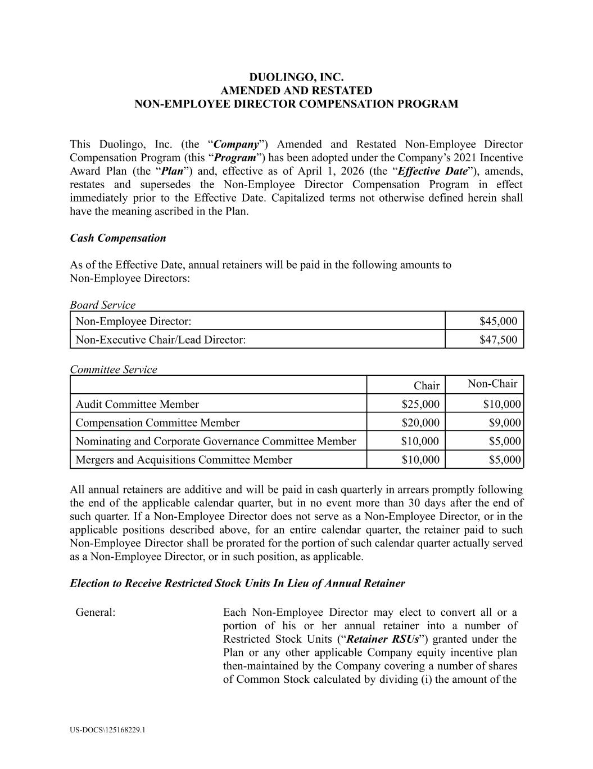
37
DUOLINGO, INC. AMENDED AND RESTATED​ NON-EMPLOYEE DIRECTOR COMPENSATION PROGRAM This Duolingo, Inc. (the “Company”) Amended and Restated Non-Employee Director Compensation Program (this “Program”) has been adopted under the Company’s 2021 Incentive Award Plan (the “Plan”) and, effective as of April 1, 2026 (the “Effective Date”), amends, restates and supersedes the Non-Employee Director Compensation Program in effect immediately prior to the Effective Date. Capitalized terms not otherwise defined herein shall have the meaning ascribed in the Plan. Cash Compensation As of the Effective Date, annual retainers will be paid in the following amounts to Non-Employee Directors: Board Service Non-Employee Director: $45,000 Non-Executive Chair/Lead Director: $47,500 Committee Service Chair Non-Chair Audit Committee Member $25,000 $10,000 Compensation Committee Member $20,000 $9,000 Nominating and Corporate Governance Committee Member $10,000 $5,000 Mergers and Acquisitions Committee Member $10,000 $5,000 All annual retainers are additive and will be paid in cash quarterly in arrears promptly following the end of the applicable calendar quarter, but in no event more than 30 days after the end of such quarter. If a Non-Employee Director does not serve as a Non-Employee Director, or in the applicable positions described above, for an entire calendar quarter, the retainer paid to such Non-Employee Director shall be prorated for the portion of such calendar quarter actually served as a Non-Employee Director, or in such position, as applicable. Election to Receive Restricted Stock Units In Lieu of Annual Retainer General: Each Non-Employee Director may elect to convert all or a portion of his or her annual retainer into a number of Restricted Stock Units (“Retainer RSUs”) granted under the Plan or any other applicable Company equity incentive plan then-maintained by the Company covering a number of shares of Common Stock calculated by dividing (i) the amount of the US-DOCS\125168229.1

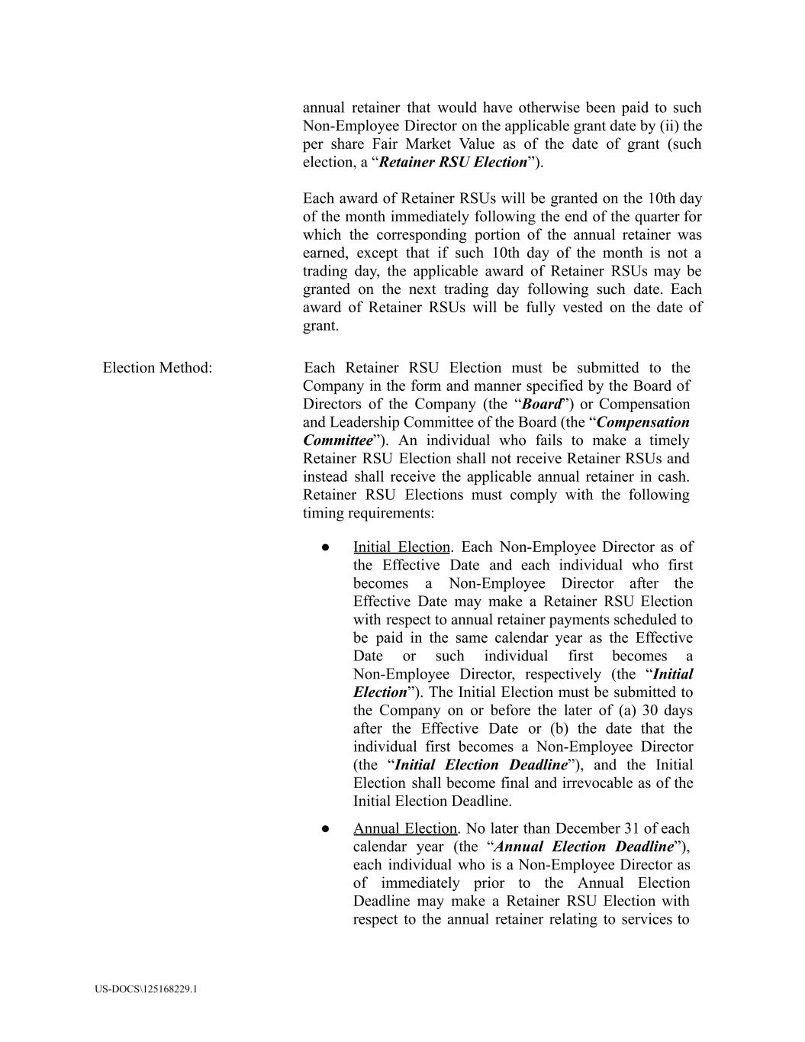
annual retainer that would have otherwise been paid to such Non-Employee Director on the applicable grant date by (ii) the per share Fair Market Value as of the date of grant (such election, a “Retainer RSU Election”). Each award of Retainer RSUs will be granted on the 10th day of the month immediately following the end of the quarter for which the corresponding portion of the annual retainer was earned, except that if such 10th day of the month is not a trading day, the applicable award of Retainer RSUs may be granted on the next trading day following such date. Each award of Retainer RSUs will be fully vested on the date of grant. Election Method: Each Retainer RSU Election must be submitted to the Company in the form and manner specified by the Board of Directors of the Company (the “Board”) or Compensation and Leadership Committee of the Board (the “Compensation Committee”). An individual who fails to make a timely Retainer RSU Election shall not receive Retainer RSUs and instead shall receive the applicable annual retainer in cash. Retainer RSU Elections must comply with the following timing requirements: ●​ Initial Election. Each Non-Employee Director as of the Effective Date and each individual who first becomes a Non-Employee Director after the Effective Date may make a Retainer RSU Election with respect to annual retainer payments scheduled to be paid in the same calendar year as the Effective Date or such individual first becomes a Non-Employee Director, respectively (the “Initial Election”). The Initial Election must be submitted to the Company on or before the later of (a) 30 days after the Effective Date or (b) the date that the individual first becomes a Non-Employee Director (the “Initial Election Deadline”), and the Initial Election shall become final and irrevocable as of the Initial Election Deadline. ●​ Annual Election. No later than December 31 of each calendar year (the “Annual Election Deadline”), each individual who is a Non-Employee Director as of immediately prior to the Annual Election Deadline may make a Retainer RSU Election with respect to the annual retainer relating to services to US-DOCS\125168229.1

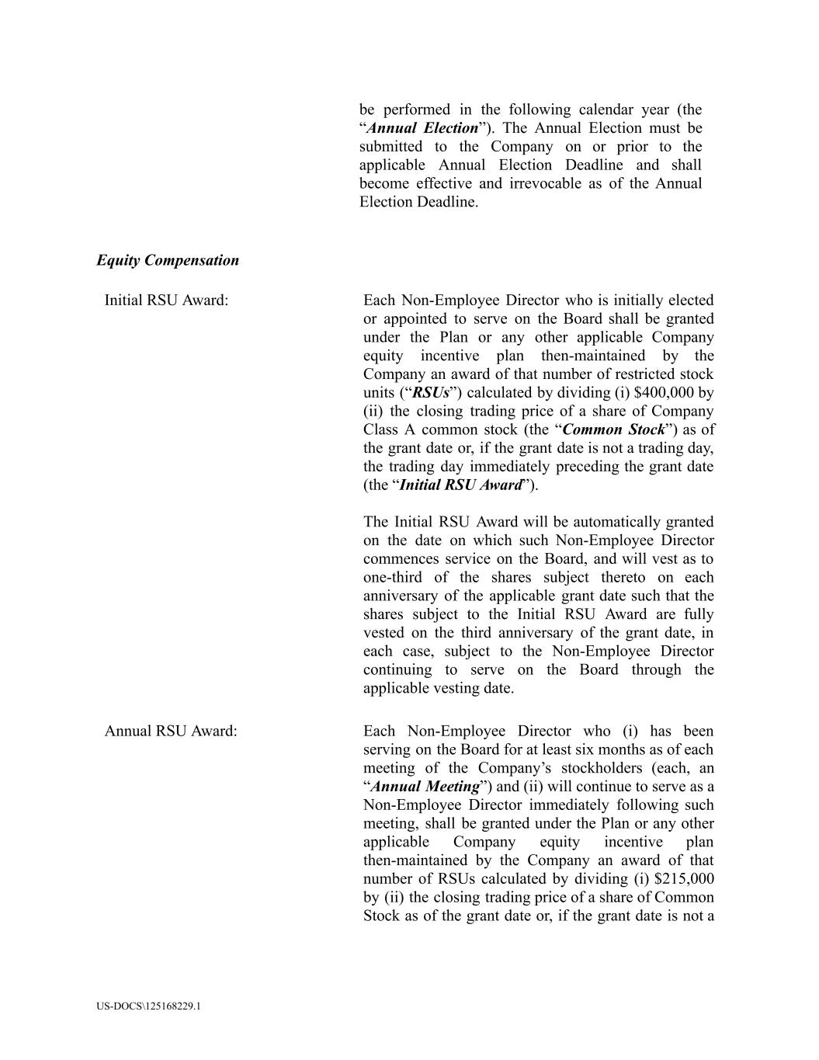
be performed in the following calendar year (the “Annual Election”). The Annual Election must be submitted to the Company on or prior to the applicable Annual Election Deadline and shall become effective and irrevocable as of the Annual Election Deadline. Equity Compensation Initial RSU Award: Each Non-Employee Director who is initially elected or appointed to serve on the Board shall be granted under the Plan or any other applicable Company equity incentive plan then-maintained by the Company an award of that number of restricted stock units (“RSUs”) calculated by dividing (i) $400,000 by (ii) the closing trading price of a share of Company Class A common stock (the “Common Stock”) as of the grant date or, if the grant date is not a trading day, the trading day immediately preceding the grant date (the “Initial RSU Award”). The Initial RSU Award will be automatically granted on the date on which such Non-Employee Director commences service on the Board, and will vest as to one-third of the shares subject thereto on each anniversary of the applicable grant date such that the shares subject to the Initial RSU Award are fully vested on the third anniversary of the grant date, in each case, subject to the Non-Employee Director continuing to serve on the Board through the applicable vesting date. Annual RSU Award: Each Non-Employee Director who (i) has been serving on the Board for at least six months as of each meeting of the Company’s stockholders (each, an “Annual Meeting”) and (ii) will continue to serve as a Non-Employee Director immediately following such meeting, shall be granted under the Plan or any other applicable Company equity incentive plan then-maintained by the Company an award of that number of RSUs calculated by dividing (i) $215,000 by (ii) the closing trading price of a share of Common Stock as of the grant date or, if the grant date is not a US-DOCS\125168229.1

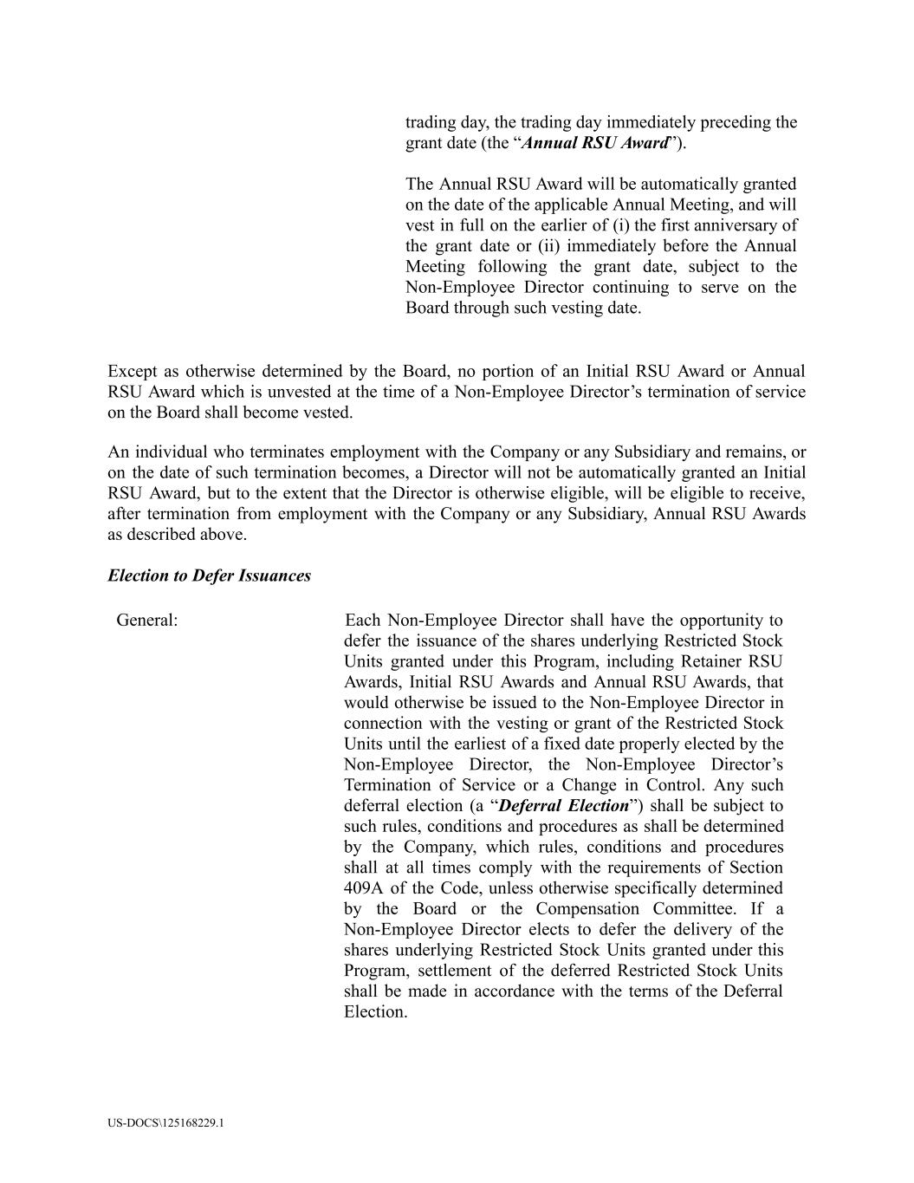
trading day, the trading day immediately preceding the grant date (the “Annual RSU Award”). The Annual RSU Award will be automatically granted on the date of the applicable Annual Meeting, and will vest in full on the earlier of (i) the first anniversary of the grant date or (ii) immediately before the Annual Meeting following the grant date, subject to the Non-Employee Director continuing to serve on the Board through such vesting date. Except as otherwise determined by the Board, no portion of an Initial RSU Award or Annual RSU Award which is unvested at the time of a Non-Employee Director’s termination of service on the Board shall become vested. An individual who terminates employment with the Company or any Subsidiary and remains, or on the date of such termination becomes, a Director will not be automatically granted an Initial RSU Award, but to the extent that the Director is otherwise eligible, will be eligible to receive, after termination from employment with the Company or any Subsidiary, Annual RSU Awards as described above. Election to Defer Issuances General: Each Non-Employee Director shall have the opportunity to defer the issuance of the shares underlying Restricted Stock Units granted under this Program, including Retainer RSU Awards, Initial RSU Awards and Annual RSU Awards, that would otherwise be issued to the Non-Employee Director in connection with the vesting or grant of the Restricted Stock Units until the earliest of a fixed date properly elected by the Non-Employee Director, the Non-Employee Director’s Termination of Service or a Change in Control. Any such deferral election (a “Deferral Election”) shall be subject to such rules, conditions and procedures as shall be determined by the Company, which rules, conditions and procedures shall at all times comply with the requirements of Section 409A of the Code, unless otherwise specifically determined by the Board or the Compensation Committee. If a Non-Employee Director elects to defer the delivery of the shares underlying Restricted Stock Units granted under this Program, settlement of the deferred Restricted Stock Units shall be made in accordance with the terms of the Deferral Election. US-DOCS\125168229.1

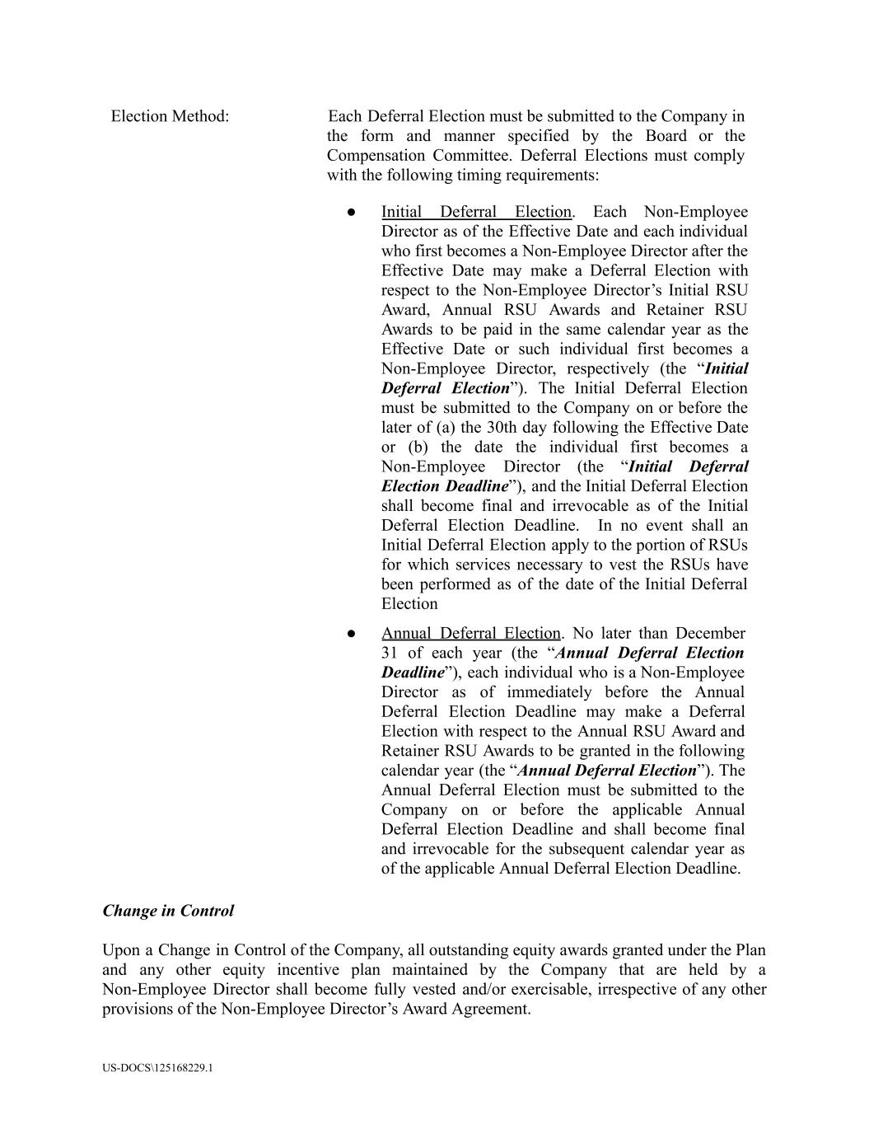
Election Method: Each Deferral Election must be submitted to the Company in the form and manner specified by the Board or the Compensation Committee. Deferral Elections must comply with the following timing requirements: ●​ Initial Deferral Election. Each Non-Employee Director as of the Effective Date and each individual who first becomes a Non-Employee Director after the Effective Date may make a Deferral Election with respect to the Non-Employee Director’s Initial RSU Award, Annual RSU Awards and Retainer RSU Awards to be paid in the same calendar year as the Effective Date or such individual first becomes a Non-Employee Director, respectively (the “Initial Deferral Election”). The Initial Deferral Election must be submitted to the Company on or before the later of (a) the 30th day following the Effective Date or (b) the date the individual first becomes a Non-Employee Director (the “Initial Deferral Election Deadline”), and the Initial Deferral Election shall become final and irrevocable as of the Initial Deferral Election Deadline. In no event shall an Initial Deferral Election apply to the portion of RSUs for which services necessary to vest the RSUs have been performed as of the date of the Initial Deferral Election ●​ Annual Deferral Election. No later than December 31 of each year (the “Annual Deferral Election Deadline”), each individual who is a Non-Employee Director as of immediately before the Annual Deferral Election Deadline may make a Deferral Election with respect to the Annual RSU Award and Retainer RSU Awards to be granted in the following calendar year (the “Annual Deferral Election”). The Annual Deferral Election must be submitted to the Company on or before the applicable Annual Deferral Election Deadline and shall become final and irrevocable for the subsequent calendar year as of the applicable Annual Deferral Election Deadline. Change in Control Upon a Change in Control of the Company, all outstanding equity awards granted under the Plan and any other equity incentive plan maintained by the Company that are held by a Non-Employee Director shall become fully vested and/or exercisable, irrespective of any other provisions of the Non-Employee Director’s Award Agreement. US-DOCS\125168229.1

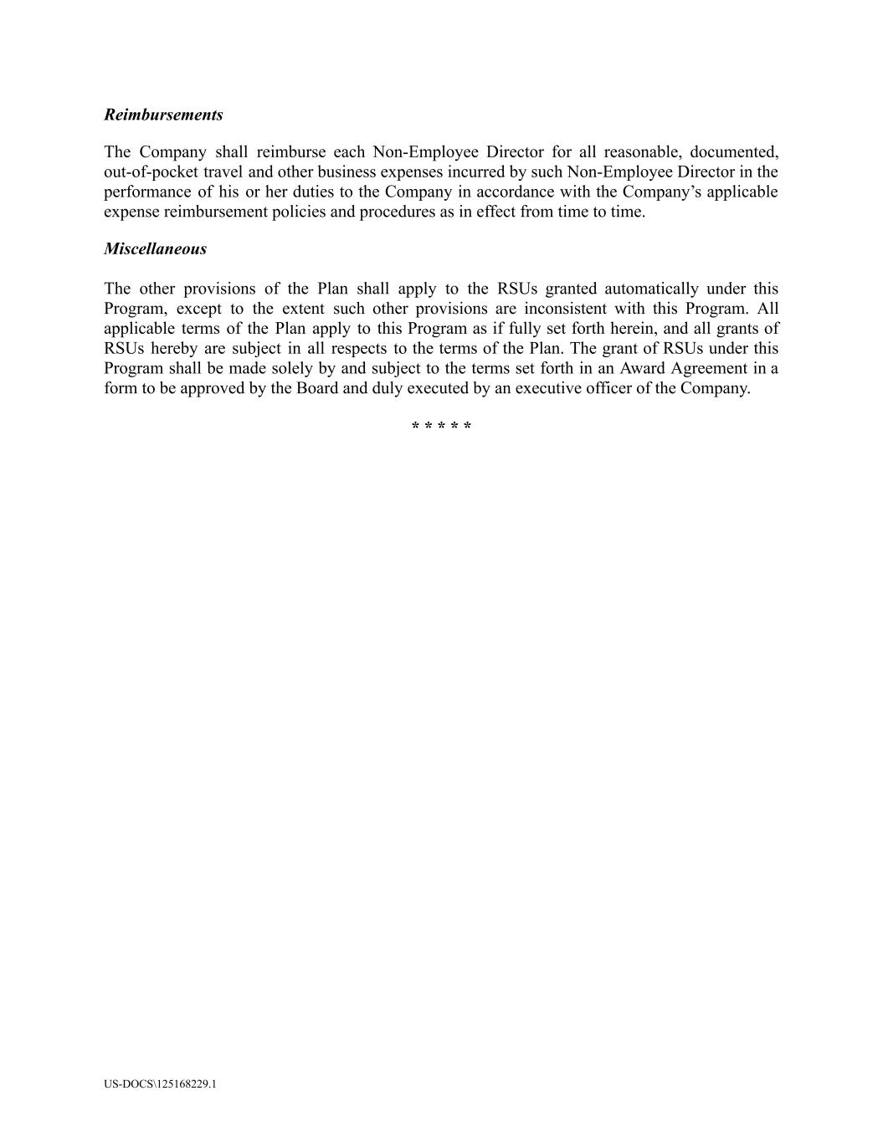
Reimbursements The Company shall reimburse each Non-Employee Director for all reasonable, documented, out-of-pocket travel and other business expenses incurred by such Non-Employee Director in the performance of his or her duties to the Company in accordance with the Company’s applicable expense reimbursement policies and procedures as in effect from time to time. Miscellaneous The other provisions of the Plan shall apply to the RSUs granted automatically under this Program, except to the extent such other provisions are inconsistent with this Program. All applicable terms of the Plan apply to this Program as if fully set forth herein, and all grants of RSUs hereby are subject in all respects to the terms of the Plan. The grant of RSUs under this Program shall be made solely by and subject to the terms set forth in an Award Agreement in a form to be approved by the Board and duly executed by an executive officer of the Company. * * * * * US-DOCS\125168229.1

Exhibit 31.1
CERTIFICATION PURSUANT TO
RULES 13a-14(a) AND 15d-14(a) UNDER THE SECURITIES EXCHANGE ACT OF 1934,
AS ADOPTED PURSUANT TO SECTION 302 OF THE SARBANES-OXLEY ACT OF 2002
I, Luis von Ahn, certify that:

1. |  |  | I have reviewed this Quarterly Report on Form 10-Q of Duolingo, Inc.;
2. |  |  | Based on my knowledge, this report does not contain any untrue statement of a material fact or omit to state a material fact necessary to make the statements made, in light of the circumstances under which such statements were made, not misleading with respect to the period covered by this report;
3. |  |  | Based on my knowledge, the financial statements, and other financial information included in this report, fairly present in all material respects the financial condition, results of operations and cash flows of the registrant as of, and for, the periods presented in this report;
4. |  |  | The registrant's other certifying officer(s) and I are responsible for establishing and maintaining disclosure controls and procedures (as defined in Exchange Act Rules 13a-15(e) and 15d-15(e)) and internal control over financial reporting (as defined in Exchange Act Rules 13a-15(f) and 15d-15(f)) for the registrant and have:
 |  |  | (a) |  |  | Designed such disclosure controls and procedures, or caused such disclosure controls and procedures to be designed under our supervision, to ensure that material information relating to the registrant, including its consolidated subsidiaries, is made known to us by others within those entities, particularly during the period in which this report is being prepared;
 |  |  | (b) |  |  | Designed such internal control over financial reporting, or caused such internal control over financial reporting to be designed under our supervision, to provide reasonable assurance regarding the reliability of financial reporting and the preparation of financial statements for external purposes in accordance with generally accepted accounting principles;
 |  |  | (c) |  |  | Evaluated the effectiveness of the registrant's disclosure controls and procedures and presented in this report our conclusions about the effectiveness of the disclosure controls and procedures, as of the end of the period covered by this report based on such evaluation; and
 |  |  | (d) |  |  | Disclosed in this report any change in the registrant's internal control over financial reporting that occurred during the registrant's most recent fiscal quarter (the registrant's fourth fiscal quarter in the case of an annual report) that has materially affected, or is reasonably likely to materially affect, the registrant's internal control over financial reporting; and
5. |  |  | The registrant's other certifying officer(s) and I have disclosed, based on our most recent evaluation of internal control over financial reporting, to the registrant's auditors and the audit committee of the registrant's board of directors (or persons performing the equivalent functions):
 |  |  | (a) |  |  | All significant deficiencies and material weaknesses in the design or operation of internal control over financial reporting which are reasonably likely to adversely affect the registrant's ability to record, process, summarize and report financial information; and
 |  |  | (b) |  |  | Any fraud, whether or not material, that involves management or other employees who have a significant role in the registrant's internal control over financial reporting.

Date: May 4, 2026 |  |  |  |  |  | By: |  |  | /s/ Luis von Ahn
 |  |  |  |  |  |  |  |  | Luis von Ahn
President and Chief Executive Officer
(Principal Executive Officer)

Exhibit 31.2
CERTIFICATION PURSUANT TO
RULES 13a-14(a) AND 15d-14(a) UNDER THE SECURITIES EXCHANGE ACT OF 1934,
AS ADOPTED PURSUANT TO SECTION 302 OF THE SARBANES-OXLEY ACT OF 2002
I, Gillian Munson, certify that:

1. |  |  | I have reviewed this Quarterly Report on Form 10-Q of Duolingo, Inc.;
2. |  |  | Based on my knowledge, this report does not contain any untrue statement of a material fact or omit to state a material fact necessary to make the statements made, in light of the circumstances under which such statements were made, not misleading with respect to the period covered by this report;
3. |  |  | Based on my knowledge, the financial statements, and other financial information included in this report, fairly present in all material respects the financial condition, results of operations and cash flows of the registrant as of, and for, the periods presented in this report;
4. |  |  | The registrant's other certifying officer(s) and I are responsible for establishing and maintaining disclosure controls and procedures (as defined in Exchange Act Rules 13a-15(e) and 15d-15(e)) and internal control over financial reporting (as defined in Exchange Act Rules 13a-15(f) and 15d-15(f)) for the registrant and have:
 |  |  | (a) |  |  | Designed such disclosure controls and procedures, or caused such disclosure controls and procedures to be designed under our supervision, to ensure that material information relating to the registrant, including its consolidated subsidiaries, is made known to us by others within those entities, particularly during the period in which this report is being prepared;
 |  |  | (b) |  |  | Designed such internal control over financial reporting, or caused such internal control over financial reporting to be designed under our supervision, to provide reasonable assurance regarding the reliability of financial reporting and the preparation of financial statements for external purposes in accordance with generally accepted accounting principles;
 |  |  | (c) |  |  | Evaluated the effectiveness of the registrant's disclosure controls and procedures and presented in this report our conclusions about the effectiveness of the disclosure controls and procedures, as of the end of the period covered by this report based on such evaluation; and
 |  |  | (d) |  |  | Disclosed in this report any change in the registrant's internal control over financial reporting that occurred during the registrant's most recent fiscal quarter (the registrant's fourth fiscal quarter in the case of an annual report) that has materially affected, or is reasonably likely to materially affect, the registrant's internal control over financial reporting; and
5. |  |  | The registrant's other certifying officer(s) and I have disclosed, based on our most recent evaluation of internal control over financial reporting, to the registrant's auditors and the audit committee of the registrant's board of directors (or persons performing the equivalent functions):
 |  |  | (a) |  |  | All significant deficiencies and material weaknesses in the design or operation of internal control over financial reporting which are reasonably likely to adversely affect the registrant's ability to record, process, summarize and report financial information; and
 |  |  | (b) |  |  | Any fraud, whether or not material, that involves management or other employees who have a significant role in the registrant's internal control over financial reporting.

Date: May 4, 2026 |  |  |  |  |  | By: |  |  | /s/ Gillian Munson
 |  |  |  |  |  |  |  |  | Gillian Munson
Chief Financial Officer
(Principal Financial Officer and Principal Accounting Officer)

Exhibit 32.1
CERTIFICATION OF CHIEF EXECUTIVE OFFICER AND CHIEF FINANCIAL OFFICER
PURSUANT TO 18 U.S.C. SECTION 1350,
AS ADOPTED PURSUANT TO
SECTION 906 OF THE SARBANES-OXLEY ACT OF 2002
In connection with the Quarterly Report on Form 10-Q of Duolingo, Inc. (the “Company”) for the quarter ended March 31, 2026 as filed with the Securities and Exchange Commission on the date hereof (the “Report”), Luis von Ahn, President and Chief Executive Officer of the Company, and Gillian Munson, Chief Financial Officer of the Company, each hereby certifies, pursuant to 18 U.S.C. Section 1350, as adopted pursuant to Section 906 of the Sarbanes-Oxley Act of 2002, that:

 |  |  | 1. |  |  | The Report fully complies with the requirements of Section 13(a) or Section 15(d) of the Securities Exchange Act of 1934; and

 |  |  | 2. |  |  | The information contained in the Report fairly presents, in all material respects, the financial condition and results of operations of the Company.

Date: May 4, 2026 |  |  |  |  |  |  |  |  | /s/ Luis von Ahn
 |  |  |  |  |  |  |  |  | Luis von Ahn
President and Chief Executive Officer
(Principal Executive Officer)
Date: May 4, 2026 |  |  |  |  |  |  |  |  | /s/ Gillian Munson
 |  |  |  |  |  |  |  |  | Gillian Munson
Chief Financial Officer
(Principal Financial Officer and Principal Accounting Officer)

